**Antti Bible**

**602  
13A**

# 

**User Manual**

**B1**

# Foreword

“A Bible - should we read one or write one - this is the question!”

Antti Lukats

The Bible is a special book made up of stories. One major difference from regular books is that the bible was not written for direct financial gain, while most books are written in the hope that it pays back in terms of money. So writing a bible is even easier than writing a (normal) book - we do not need to worry about the sales! Also, there is no need for a single theme for the book, just a collection of shorter stories is sufficient. Antti Bible seeks no financial gain, it is written because I wanted to write it. In the hope that my children will read it. That's all that matters. My name is Antti, so my bible is an “Antti Bible”!

"Writing is perhaps the greatest of human inventions,

binding together people, citizens of distant epochs, who never knew one another.

Books break the shackles of time.

A book is proof that humans can work magic."

Carl Sagan

## 

# How it started

This is what the cover page looked like in a draft version that started in January 2015.

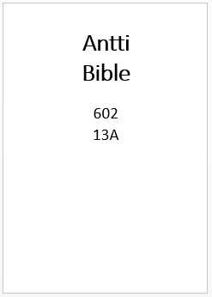

And this is the text from the first page:

If you did understood the dedication written on the cover of the Bible  
**602  
13A**

in the very instant you looked at it; then we: humans, are no longer alone on planet Earth.

A Bible – you can either read one or write one.  
I am the one who writes it.  
My name is Antti.

The Bible and religion have helped humans to understand the world that existed around us.

That Bible does not help to understand the world we humans are creating right now.  
This Bible does.

## Year ZERO and Greta’s day

It’s autumn 2019, Greta Thunberg’s time.

She got an insect named after her (“[Nelloptodes gretae](https://science.orf.at/v2/stories/2993515/)”). 

She did not get the Nobel Prize. I can not change that. But there is something I can do.

I can give Greta her own era.

By saying that year 2019 is year 0 Anno Greta. Done. Now Greta Thunberg has its own era/calendar. It is easy to convert from Greta's calendar to our normal calendar: day/month remains the same, from the year we subtract 2019. Like this:

2019 = 0 AG

2020 = 1 AG

…

That’s the math! Hey, but nobody uses this Greta’s calendar? Nono, this is not true - I use it, so it is in actual use. It does not matter how many of us use Greta’s calendar, it is sufficient that one person does. I do and this counts.

I can do something more, I can give Greta her own day too! Done, September 24 is Greta’s day! It is marked in my Google calendar.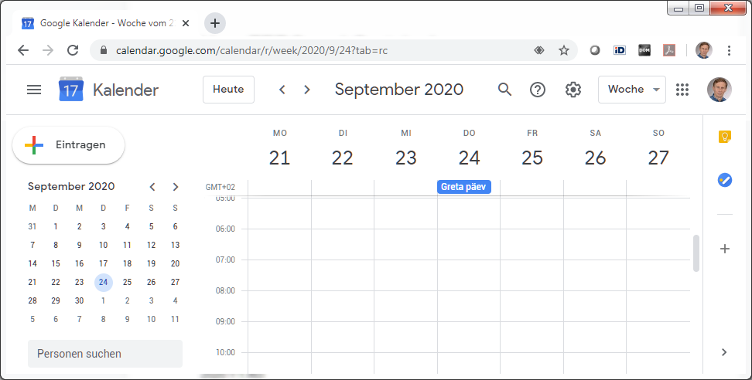

“Hi Greta, do you like your Day?” I wish I could ask her this, but this remains a dream.

## Obama Day

In June year one Anno Greta just before the birthday of Donald Trump some Twitter user(s) suggested naming Trump's birthday on 14 June to **#ObamaDay** and post pictures of Barack Obama on Twitter just to make Donald Trump mad. I guess the ObamaDay Twitter hashtag was successful, there were a large number of pictures posted.

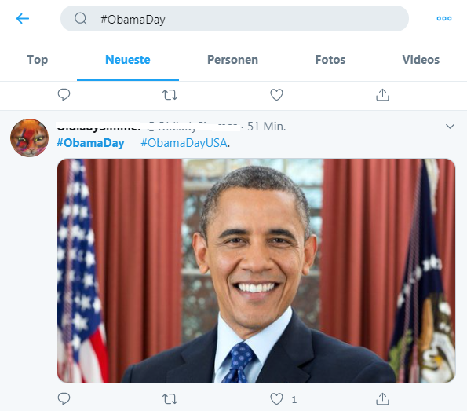Barack Obama has now already three days as Wikipedia lists 4th August and 2nd November Monday as “Barack Obama Day”.

Well, I like that 24 September is Greta’s day, it brings a smile to my face.

Sometimes it’s the small things that count.

## 

## Forecast for year One

At the end of year zero, I made a blog post with a forecast for year one. It said year one will be better than year zero unless Donald Trump starts a major war. I could not have been more wrong! There is no major war but for sure year one (2020 AD) is much worse than the previous year. It is safe to say year one is the worst one in modern history (after world war II). The forest fires are larger, the political situation is worse, the United States of America is a total mess and on the verge of civil war thanks to Donald Trump, and of course there is COVID 19 Pandemic and its influence on global economics. And [Doomsday’s Clock](https://thebulletin.org/doomsday-clock/current-time/) is advanced to its maximum setting 100 seconds before midnight indicating the most risk on the survival of the human race on planet earth.

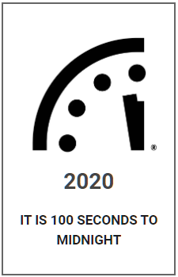

## Forecast for year Two

It's the end of year one, what will year two bring? We are living in the second wave of the Covid-19 pandemic, the vaccine rollout has just begun. There are two new mutations of the virus. Still, year two should be better than year one. Joe Biden as the new president of the USA gives some hope that international relations will be better. Well, Joe Biden has given lot's of promises: like that the USA will rejoin the Paris agreement. It is to be seen what he really fulfills. But there is hope.

## Year TWO

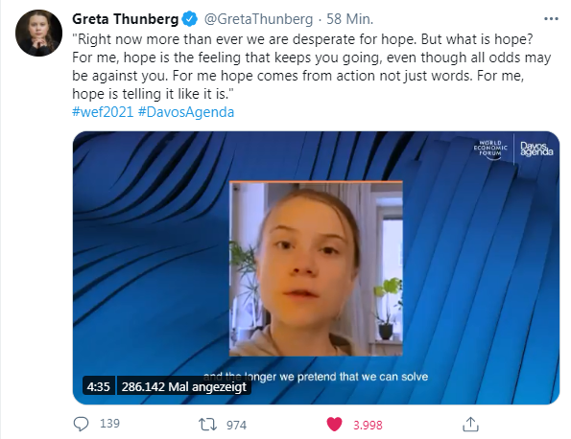

Greta's message to the DAVOS world economic forum annual meeting. I listened to the complete message. Pretty much sad. Sad that a girl has to say that to the world leaders. A very short version: [The set] Targets equal to surrender. You can not negotiate with physics.

A very good response to Greta’s tweet:

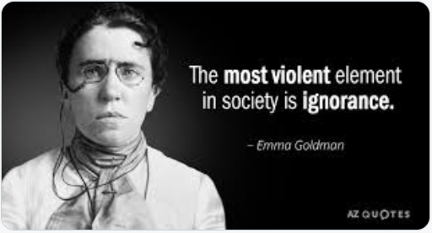

This sums it up. Only a ignoranant society makes it possible that our planet is so messed up as it is right now.

In year two Twitter permanently disabled Donald Trump's account. I would have closed Trump's account in year zero when he tweeted that Greta is a very happy young girl… Really back then when I did see that tweet from the official POTUS account I was stoned. Greta was a Kid who has **given away his childhood** for the fight for the better future of our planet. Trump’s tweet to Greta was just disgusting.

Donald Trump was voted out of the White House in year one, but there are still too many of his supporters and trumpers at power in the USA.

There is one thing I did think Joe Biden would do, namely release Reality Winner, but within more than a month nothing happened, so I tweeted myself:

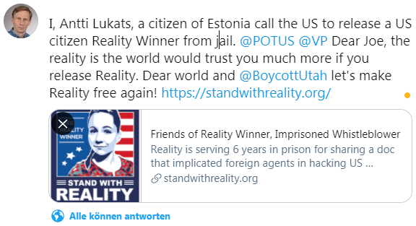

BoycottUtah is the handle of Richard Saunders who did tweet 1000+ times to call for removal from office of Donald Trump. Nothing happened, but he did not give up tweeting. I am now tweeting **every day**, adding the day# count in the front of the tweet. I really take this as a test for president Biden, if he does not issue a release of Reality Winner, we can really not count on him. I kinda hoped that he would not fail this test, but now it seems I was too optimistic. Well I really hoped Joe Biden would release Reality, and for sure I am not the only one who hoped that. We are many.

# 

# First Century

In Greta’s era, the first century is 2020-2119 AD.

What will happen in the first century? What can we say today at the beginning of the century? What will happen in the next 100 years? Many big things are coming as the pace of development increases all the time.

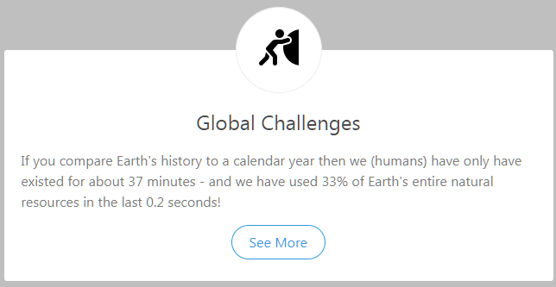

What happens in the next few years will be crucial for all of us living on planet earth.

## Bees

It has been said that humans die two years after bees. In year two the wild bee reproduction has decreased by 89% due to pesticide being used for soil in some countries. The amount of insects at least in Germany seems to have reduced a lot, in the years 0 and 1 the amount of insects was alarmingly low in the summertime. It is said that the biomass of insects has decreased by 74%. This number is now possible even bigger.

## Smoking

Will smoking decrease in the next 100 years? Most likely smoking and other uses of tobacco products will decrease in the first century. Tobacco prices are going only up and there are severe restrictions on where it is OK to smoke. And there are anti-advertising pictures on the packaging of tobacco products. Of course, there are big differences in cigarette prices between countries, for one pack of cigarettes the price can vary from 1 USD (Nigeria) to 25 USD (Australia). I truly hope that during the first-century smoking loses popularity and decreases a lot. It makes sense to use the land for other products and not for tobacco.

## Faith in God

In the first century faith in God will decrease. Many more people will realize that God is not real and that we, the humans alone are responsible for the damage we do to our planet and nature.

## 

## Slavery

Slavery is not something from the past, it still exists in the modern world.

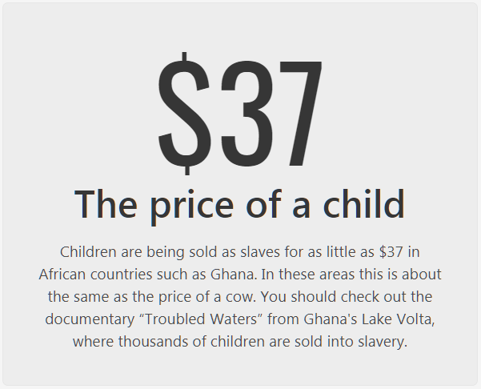

In year one there are more than a million children sold as slaves every year, and more than 20,000 are killed each year while working.

UN has an agenda targeting to stop all kinds of child labor by year 5 and all forms of modern-day slavery and human trafficking by year 10.

Things are going in the right direction but the UN agenda will remain a noble goal with current trends.

Slavery will end during the first century, but it will not happen in 5 or 10 years, it takes longer than that.

## Deforestation

Trees are cut down or burning at an increasing rate:

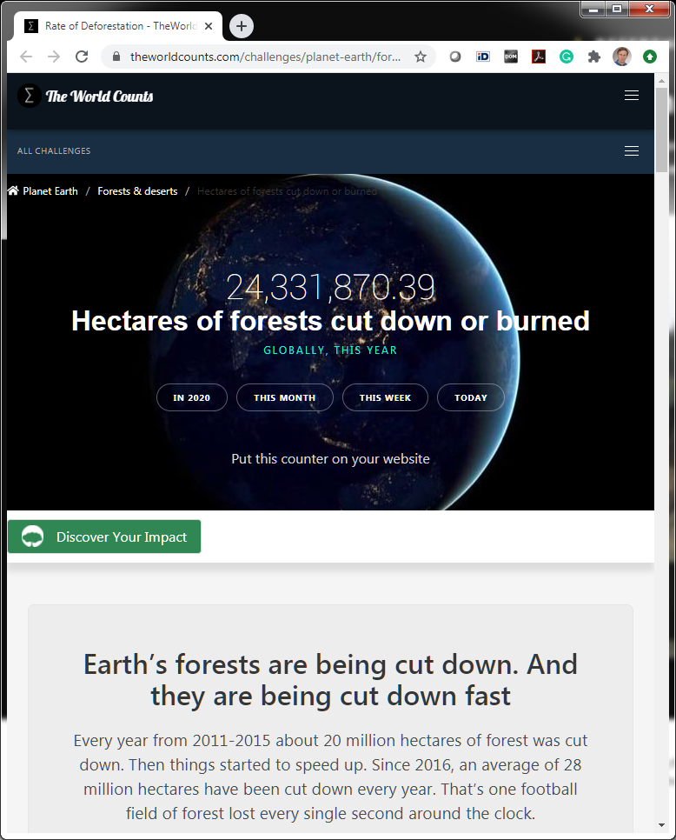

More than one hectare of forest is destroyed every second. So over 1500 trees die every second all the time. It makes 40 billion trees per year. There are 34% of wild forests left.

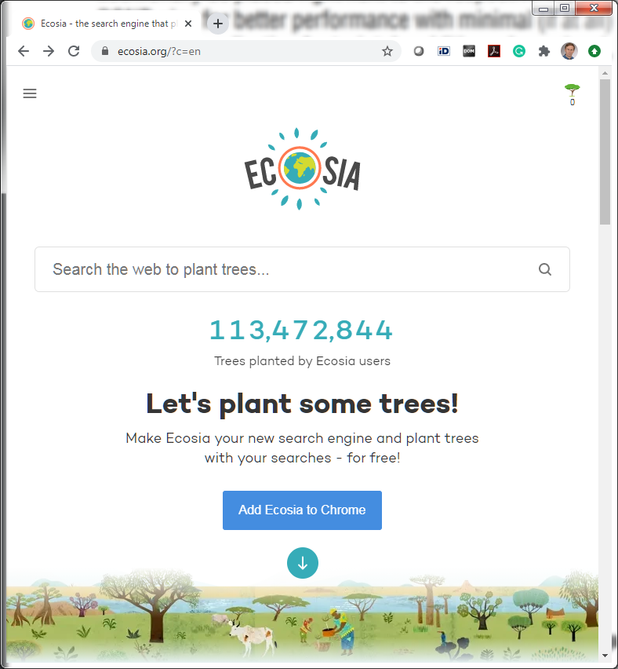

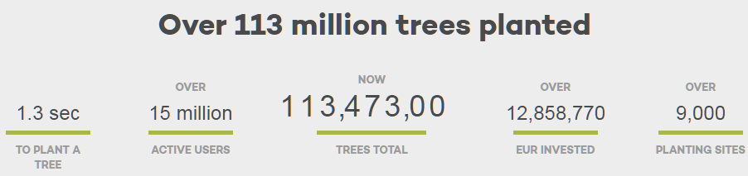

This is an interesting concept: revenue generated by page view ads is used to plant trees. By using an ecosia search engine you plant actual trees! What is the impact of ecosia? Pretty small taken into account that 40 billion trees are destroyed annually. But every planted tree counts!

At the current rate, we have no more (rain)forests in 80 years (some forecasts predict as soon as in 30-40 years). Up to 75 percent of life on the planet lives in rainforests. Most of these millions of species - many still undiscovered by humans - would be wiped out if the rainforest disappeared. There would simply be nowhere else to go. Deforestation is a major source of climate change, about 300 billion tons of carbon is stored in trees. That’s 8** times the total annual global CO2 emission. When trees are burned or decomposed, the carbon is released into the atmosphere. Deforestation is the second largest human source of increased CO2 levels after the burning of fossil fuels.

Interesting that 54% of the forests are from only 5 countries.

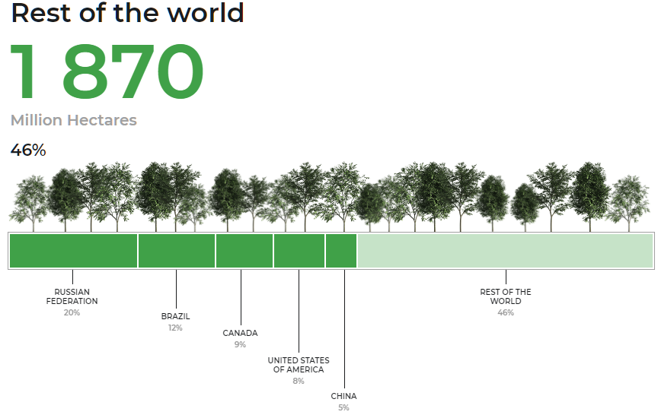

So if those countries save forests it would have a large overall impact.

## No more fish

If overfishing does not stop we run out of fish before year 30. Nearly 80% of the world's fisheries are already fully exploited. The modern fishing fleet has enough capacity for 4 earth-like planets! There is no way the oceans can sustain the growing demand from the growing population unless major changes take place.

## Water shortage

There will be no water (freshwater) in year 20 if we keep doing what we’re doing today. Most of the water is used by the production, as an example, it takes more than 15.000 liters of water to produce one kilo of beef. One A4 sheet of paper requires more than 10 liters of water.

## Too much paper

We produce huge amounts of paper each year with an ever-increasing demand. In the USA, Japan, and Europe an average person uses more than 200 kilos of paper each year. In some countries, it is as low as 1 kilo per person. The environmental effects of paper production include deforestation, the use of enormous amounts of energy and water as well as air pollution and waste problems. Paper accounts for around 26% of total waste at landfills. Paper is easy to recycle, yet 55 percent of the global paper supply comes from newly cut trees.

## The end of oil

If nothing changes we run out of oil in about 50 years. And if we continue to burn all the world’s oil there’s little chance to save the climate from runaway global warming. We need to reduce the emissions of greenhouse gasses very significantly if global temperature increases are to be kept at 2 degrees Celsius in the first century. We must start using more renewable energy. Time is pretty much running out. There is some progress as 27% of electricity is already produced from renewable sources. But the end of oil will be very hard on humans as we depend so much on cheap oil.

## Obesity

There are more than 800 million people who are obese (simply put fat). More than one out of 8. Worldwide obesity kills almost 5 million people annually. That’s about 8% of global deaths.

## Hunger

Globally, more than 800 million people suffer from undernourishment. Around 9 million people die from hunger and related diseases. The UN has set a goal for Zero Hunger by year 20, but it will be a huge challenge.

## Cashless world?

It is clear that the use of cash payments will decrease a lot in the first century, with several countries going cashless or almost cashless. But could it be that all the world goes cashless in the next 100 years? For sure some countries go virtually cashless.

## Weapons

There are way too many weapons in this world. We should really reduce them.

What if the USA would make the following statement: We will disable and eventually dismantle all our nuclear weapons. What would happen? There would be about 45% less nuclear weapons in the world. The USA would save lots of money as they do not need to maintain their nuclear weapons anymore. No country would attack the USA. But other nuclear weapon countries may not follow? So what. The one that gets the benefits is the USA, no matter if other countries follow or not. And at some time other nuclear weapon countries may reduce their warheads as well. It is really expensive to maintain nuclear weapons over a long period of time. The electronics in the warheads last for long, but not forever. Replacing the electronics is not an easy task. There are other parts of the warhead that need either replacement or maintenance regularly.

But then it may happen that North Korea is the last nuclear weapon country? If so, even that doesn't matter. Whatever can be done to reduce the number of nuclear weapons should be done. The nuclear weapons, it's just insane that they exist at all.

In the year ZERO US warplanes dropped **7,423** bombs and other munitions on Afghanistan.

What if the USA would make the following statement: We will reduce the amount of bombs and missiles to 30% and our total military spending to 50%. The US would remain the country with most military spending in the world. The funds saved from the military could be used for education in the US. Does not happen? Not in 100 years? Well in 100 years US military spending will reduce for sure. But it could happen as soon as now also. Right now the US is spending more on the military than the next 10 countries combined.

## Overpopulation

This is the most burning issue we are having. There are just too many of us on our planet. And the population keeps growing. How to reduce the growth? In year one Venezuela's minimum wage is 13 USD a year and a pack of 3 condoms cost 4.40 USD there. And there are plenty of countries where the yearly minimum wage is below 1000 USD. The population growth happens mostly only in the poor countries. But when life in poor countries gets better then also the average age will increase there making the population grow again. All projections show the population growth to continue. This will of course make all the problems we have more severe.

## Sperm quality

In the years from 1973 to 2011 the sperm count of average men in western countries had fallen to 59%, also the quality of eggs is decreasing. The problem is in chemicals called endocrine disruptors, they are everywhere: in plastics, shampoos, cosmetics and canned foods. Not only there is decline in sperm counts, there are more sperm with two heads, and some are just swimming around in circles. Tests with mice did show 20% of the mice were infertile after three generations. It is to be seen what happens with us humans in 100 years.

## Genome degradation

Human genome is degrading. The average newborn has 50-100 new mutations from which 1 to 4 are harmful. Normally natural selection causes people having those mutations to die out or not have children, but our lives aren’t natural anymore. People with harmful mutations live longer and have more children. It is estimated that human health/fitness decreases 1 to 3% per generation.

## Moores’ Law

Published by Gordon More in 1965 it states that the number of transistors per chip doubles every two years. [Moore’s Law](https://en.wikipedia.org/wiki/Moore%27s_law) implies that computers, machines that run on computers, and computing power all become smaller, faster and cheaper with time. Some other implications are that the new chips use more power, become leakier, are more fragile and more sensitive, and they are much more difficult to manage and protect.

## Digital Twin

Definition from the [Digital Twin Consortium](https://www.digitaltwinconsortium.org/): A Digital Twin is a **virtual representation of real world entities and processes**, synchronized at specified frequency and fidelity. A digital twin is the bridge between the physical and digital world. It can very well be that the digital twin technology may play a major role in our lives in the first century.

## 6G Mobile Network

In year 11 (2030 AD) commercial use of 6G networks is planned.

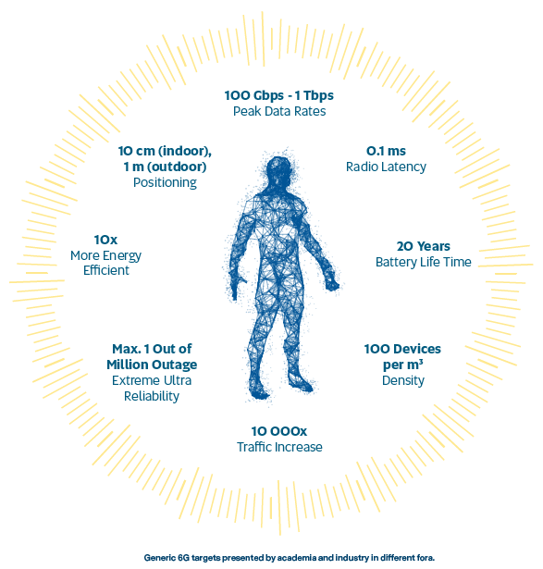

The feature plans for the 6G mobile network seem close to insane. Users will accept an alternative version of reality that enhances their ability to consume media… Sounds like science fiction? Well it's the future. Interesting the link range for 6G depending on the frequency band may be less than 1 meter. By some means the digital twin technology comes into play as well. Of course the use of AI is also part of the 6G game. The digital and physical worlds will be deeply entangled, and people’s lives will depend on the network. Malicious cyber activity could lead to loss of property and life. Sounds cool?

## VR, AR and MR → XR

Virtual (VR), augmented (AR), and mixed reality (MR) are merging into XR (Extended Reality). It’s coming and it will reshape our world as we know it.

## Copyright & Patent

During the first century all current copyrights and patents will expire.

# 

# First 100 Million Years

Can humanity survive 100 Million years? Let’s assume we can. What can we know for sure about what happens in those 100 Million years from now? What problems would we face?

## NOMIL

What we can say for 100% sure, in the year 100,000,000 AG there would be no military at all. It will be a NOMIL (**No** **Mil**itary) world. No Navy, No Space Forces, just no military at all. There is no need for any military forces in a humane world.

How do we get to NOMIL? This will happen sooner or later as it is not possible to sustain a weaponized army for 100 Million years. It may happen much sooner, actually it may happen almost any day. There are many scenarios possible. Step one would be getting rid of Nuclear Weapons. Surprisingly this is possibly the easiest step, as there are drivers that make it more likely - the maintenance costs.

The USA could say one day: We reduce our nuclear warheads to zero. This would be of benefit for the USA in the first place. Not gonna happen? But it could equally well be that Russia makes the first step and reduces it’s nuces to zero. Russia has even more to gain than the USA with such a step. Not gonna happen? Not in a thousand years? What about 2000 years? The maintenance of active nuclear warheads is a costly luxury. The idea to zeroize the nuces will come.

[deleted]

[deleted]

...right now I remembered one more item from my todo list from 12 April: HUMAN, ah and ARTI ?

# 

# Saving the World

“Together we can save the World.”

Antti Lukats

It’s 17th June, year one Anno Greta (the year 2020 AD) - I have finally figured out what I want-to-do in my life - I want to save the World! What about You? Ask yourself one simple question: Would you like to save the World? Do not think about how, just ask this simple question. I think most of us would answer this question: “Yes, I want to save the World”. This means that most people would like to save the World. So why aren't we all doing it? Let’s change it, let’s start! Take a deep breath, drink a glass of water and say to yourself: “I want to save the World!” Did you manage that? Congratulations! We are now one step closer to saving our World, thanks to you! Because you just announced your willingness to do something that may have an impact on our World. It doesn't matter who you are, your willingness to act may at some certain time be all that is needed to save our World. The thing you have to do may be something very small and simple, something you certainly can do.

You are now the savior of the World - when action is badly needed you would act.

Our World is sick and broken and there is no big positive change in sight. The Climate is in crisis, it seems no way the Paris Agreement goals will be reached. Earth temperature is rising, polar ice-caps are melting, permafrost is melting and the process is accelerating. No scientist can precisely forecast what our future brings. Brazil is destroying rain-forests, there are large forest fires each year. Our oceans are polluted with plastic. Our nature is dying on us.

Most countries have severe internal problems - be it corruption or something else. It’s not better with international affairs either - there are trade wars and other issues.

There are too many weapons (nuclear and conventional) in this World and too much military. There are wars pretty much ongoing in some parts of the World at any giving time.

There is too much violence and cruelty in this World.

The World’s population is growing and there are more and more people hungry in poverty.

Please think a bit - can you find just one thing you for sure know would be better in our World say in the next 5 years? In 10 years? The way it looks today in year one the future of our World is not very promising.

A change must come.

## Hope for Tomorrow

Learn from Yesterday.

Live for Today.

Hope for Tomorrow.

The important thing is not to stop questioning.

Albert Einstein

Life always offers you a second chance.

It’s called tomorrow.

Unknown source

There is always hope.

If things go worse and worse then a day must come when they go better again.

Antti Lukats

If you made up your mind that you want to save the World, then you can help the World by staying alive for tomorrow. Each day you live brings you closer to the better World. This is the basic recipe - stay alive and be prepared to do your part when the day comes your action is needed to save the World.

You should not try to save the World today and alone - this simply isn't possible (no matter who you are) and could be pretty much dangerous to your mental health.

There are websites, organizations, and books named/titled “Hope For Tomorrow” but what inspires me is one Twitter user:

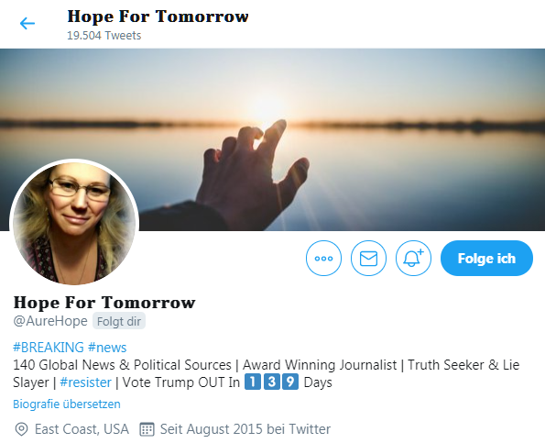

She tweets every day in the hope of a better tomorrow for the USA. The response to those tweets is very low - many of her tweets get only one like. But she is not giving up, she is tweeting and tweeting in hope. In the hope to make a difference. It seems that nobody is listening (almost no likes!) but she just goes on.

So should we all. There is hope. Hope for a Better Tomorrow.

In year two she changed her handle, profile and background pics and added a link to her amazon shop. So this user is using her account for money making using amazon. It's not about the world or America she is fighting for, it's all about personal benefits. It makes me a little sad, I truly did think she really cares about a better tomorrow. Maybe she does?

But it doesn't matter if one Twitter user uses "Hope for Tomorrow" as a slogan for her webshop.

There truly is hope for tomorrow. There is. **This is something we all should believe in.**

## Hope A. Freedom

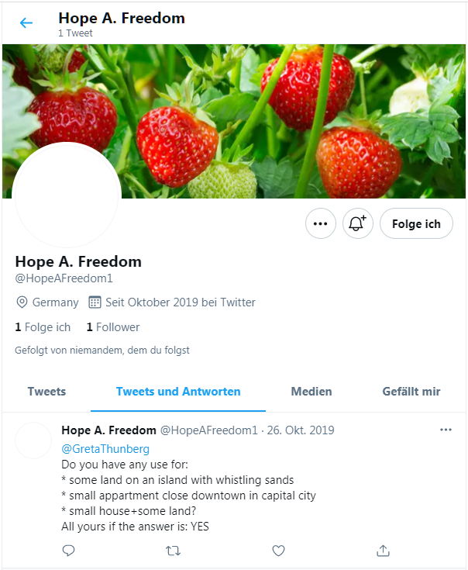

X



## 

## HOWTO: save the World

Have you heard about SMART goals? I did hear about them about a week ago, and googled them yesterday: **S**pecific, **M**easurable, **A**ttainable, **R**ealistic and **T**imely (SMART). How smart is it to set “saving world” as a goal? What can we really do to save the world? What can I do? What will it change? What can one person change? Sometimes a very small change can have a large impact. At a critical moment, one person can save the world.

Greta Thunberg is fighting to save our planet. She is not alone but she is also not getting sufficient support to make a real change. The world is not ready to listen to her.

I am looking at this, trying to focus my thoughts:

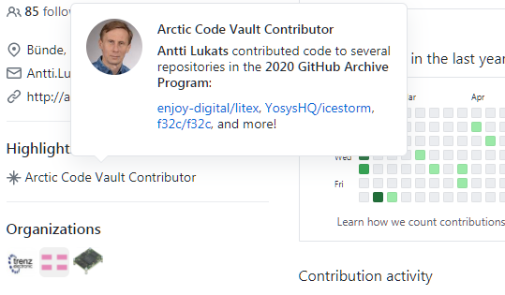

This is a [Github](https://github.com/) “badge” saying that some of the code contributed by me is selected to be stored in a coal mine deep beneath an Arctic mountain in Norway. Archived on hardened film, designed to last for 1000+ years.

If some of the code written by me is selected to last 1000+ years, what if “Antti Bible” lasts for 1000+ years? There is no way to push "Antti Bible" into the Arctic Vault. But a good book can withstand the time if people keep reading it. I am looking at a piece of paper I wrote some notes while looking at a video from lifehack:

* Focus on Positive, Think Positive!
* Success starts with a Goal

So, time to (re)set the goals! What if I set as goal the preservation of "Antti Bible"? I can not make all people read the Antti Bible. But one thing is sure if all people would read the Antti Bible the world would be a better place. I am sure of that. Positive!

With a smile for you all :) → please, please take this smile and **PAY IT FORWARD**.

Can you do this for me? For you? For the world? Smile to the world? Give it a chance!

I’m smiling again. How about you, feeling a bit positive? Need another smile? I am trying to insert a smiley in Google doc . On the second attempt I succeeded. I feel good.

I succeeded in inserting emoji! Despite almost giving up on the first attempt. Giving up is not an option. If I want to save the world I should do my best for that goal. The best I can do is to write a Bible. What I am doing already right now. As I am writing a Bible I do not need to be worried about sales, as I want it to be free for everyone to read. But of course, I have to distribute the Bible by some means. And I have to make sure it is preserved for next generations to read. How? Could I ask my children to keep a copy of the “Antti Bible” available online for everyone to read? Of course, I can upload the Antti Bible to GitHub and some other places, but I can’t guarantee that those download locations keep storing it after my death. Can I ask the world? Why not?

So dear world, please store a copy of “Antti Bibble” to be available free of charge.

Thank you!

In 2008-2009 I wrote a monthly magazine titled “Antti Brain” - yesterday I uploaded archive copies from the old backup drive to GitHub and made a posting on Linkedin. I did not get many responses, but one did make my heart warm:

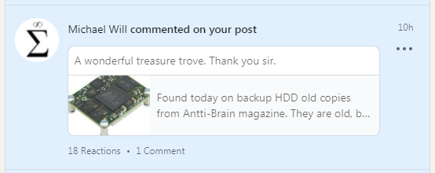

We should give away things we do not need. We should publish our work. And not worry.

Back to the goal-setting and to the **S** letter from SMART: Specific. The goal should be specific. I want to save the world is not specific. Writing a book (or Bible) that makes the world a little bit better place to be is a specific goal. Set!

Next letter **M** - measurable. How do you measure the success of a Bible? Well, one for sure no existing Bible (or another holy book) has succeeded to make the world a better place, they all failed. Does the Antti Bible succeed better? Was it a smile on your face? Yes, just now. If yes then I have succeeded. And I can set the measure of success of the Antti Bible as follows: five thank-you emails from random readers. Done with the letter M, the goal is now measurable. That wasn’t that hard!

Next letter **A** - attainable. This is easy, I am writing on Google docs, this is a free service. I can later convert the document into PDF or ebook format, this is also a free service.

Next letter **R** - realistic. Can I expect to receive 5 thank-you emails? How realistic is it? There is a 1:100 ratio, from 100 people who read only 1 will respond. So I need 500+ readers to get 5 responses. How likely will I get 500 readers? I am not good at advertising and I do not have many followers on my social media accounts. But I think if I take it seriously this time, I can drive some attention. So, let’s say the goal is realistic.

Next letter **T** - timed. This is harder, how do you define when the Bible is ready? Should I set a word count limit? Or a time limit? Must be a time limit, as timed implies that. No, it isn’t harder at all. Say the time limit is year two Anno Greta, so I have 11 months to finish.

The goal to save the world is now redefined as a SMART goal. Amazing.

What about goals in your life? Are they SMART? Can you redefine them as SMART goals?

Why Set Goals? (blatant copy from public domain document **Setting-Goals.pdf** follows...)

Goal setting can:

* add value to the work that you are doing
* help disseminate the workload more evenly
* allow you to assess your progress along the way
* help you figure out how to move forward if you encounter drawbacks
* manage your time more effectively which can diminish burn out or needless work

for you or your group

* establish what you are trying to accomplish
* clarify the definition of success
* develop clear purpose which can help with recruitment of volunteers or

community partners

* inform budget development and, identification of resources
* demonstrate that your organization is going to provide manageable tasks
* help you work smarter not harder

I can truly say that setting a SMART goal really helps.

It works. A realistic, specific, timed goal. SMART!

## 

## World3

This is a system model of interactions between population, industrial growth, food production and limits in the ecosystems of the earth. It was produced in 1972.

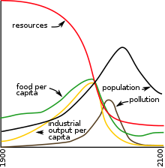

This is one run of the World3 simulations. No matter how we look at this diagram, and no matter how inaccurate it is, it still shows that major issues are on the horizon now.

# 

# Rules of Life and other Rules

We all feel the oppressive presence of rules, both written and unwritten – it’s practically a rule of life. Could we live in a world with no rules? The short answer is no. We need rules and norms, or it would all end up in anarchy. What may be a problem are the unjustified rules. The tricky part is to recognize the difference. Not all rules are to be broken, but sometimes we should question them.

See also:

[Could we live in a world without rules?](https://theconversation.com/could-we-live-in-a-world-without-rules-128664) At [Life’s Big Questions](https://theconversation.com/uk/topics/lifes-big-questions-80040) / [The Conversation](https://theconversation.com/)

## 

## R.O.L. AD 2001

My Rules of Life published in 2001. The old webpage is still archived by [wayback](https://web.archive.org/) machine.

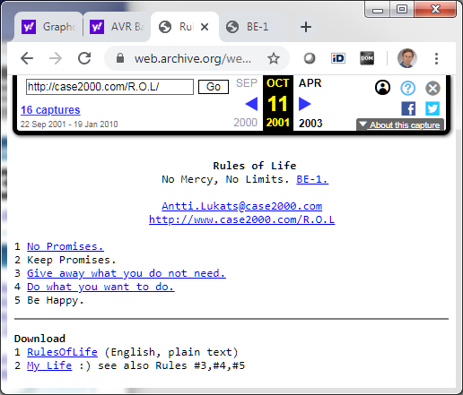

In the downloads section, there is the plain text of the rules and there was also a link to my past life projects and quellcode that I wanted to make public (give away for free). So the “Download my life” was not meant to be a joke, I really wanted to give rights to my IP (Intellectual Property) away for free on that download link. I started this process also, but someday I stopped and the domain name expired. Today most of the stuff that was supposed to be made public is still on some old backup Hard Disk drives. Some of it is lost as my mother did put my PC on the fire once. She did think that the PC was guilty that I had a breakdown. I didn't say a bad word about that.

UPDATE Year two: I started to push my old stuff to GitHub as “extras” to the Antti Bible. Better late than never.

Here is the full-text version of the rules with a mini-FAQ.

Rules of Life

No Mercy, No Limits. BE-1.

Antti.Lukats@case2000.com

http://www.case2000.com/R.O.L

1 No Promises.

2 Keep Promises.

3 Give away what you do not need.

4 Do what you want to do.

5 Be Happy.

[To be Continued]

- - - - - - - - - - - - - - - - - - - - - - - - - - - - - - - - - -

LEGAL DISCLAIMER

1 You are authorized to modify the Universe.

2 You are NOT authorized to modify this document "RulesOfLife.txt".

3 Whatever happens [if you follow the R.O.L.] is up to YOU.

- - - - - - - - - - - - - - - - - - - - - - - - - - - - - - - - - -

F.A.Q.

Q: Who wrote R.O.L. ?

A: me.

Q: Why?

A: Because I wanted to. (see also rule #4)

Q: Are you following R.O.L. ?

A: No. (see also rule #4)

Q: Are there more Rules?

A: Yes, but I forgot them.

:A)ntti Lukats, 21st August 2001, Tallinn, Estonia

I think from one of the links there was a page where I was giving away a free smile.

That page is no longer online so here comes that extra smile for you:



## 

## 5 Second Rule

(Transform Your Life, Work, and Confidence with Everyday Courage)

A book by Mel Robbins

The Book, PART 1.1: Five Seconds To Change Your Life

The rule itself: If you have an instinct to act on a goal, you must move within 5 seconds or your brain will kill it. That’s it, that’s the 5 second rule.

Simple? Well to understand it in more detail you have the following options: You can watch [Mel’s TEDx video](https://www.youtube.com/watch?v=Lp7E973zozc) (22 minutes, over 26 Million views), you can “[look inside](https://www.amazon.de/-/en/Mel-Robbins/dp/1682612384)” in the book itself, you can read the book reviews, and you can read [Mel’s blog](https://melrobbins.com/five-elements-5-second-rule/). Of course you can buy the book also.

From the comments: The entire book could be written in one page: count down from 5 to 1 and do whatever it is that needs to be done. Only the title is worth your reading time. The 5s seconds rule is a very simple idea that could be explained in 5s.

For me it is not clear why we do have to count down, why can't we just move on instantly doing what we have to do? Why that countdown? Well there seems to be some medical [explanation about our brain](https://melrobbins.com/5-second-rule-hack-science-explained/) that explains why the 5 seconds rule actually works.

I haven't read the book, I tried to watch the TEDx video,it started like this:

*Oh my God!*

*Hi everybody!*

*How are you?*

*Oh my God!*

*My name is…*

This is where I stopped watching.

## 1 Minute Method

You want to be healthier, do more sports, start something new but you find no time and/or motivation? Can you spend one minute a day? We all can find one minute each day no matter how busy we are all day. So the 1-Minute method is very simple: do something for one Minute each day. Like a small exercise. You can not find any excuses not to spend this one Minute. This method is described in more detail on the [skillupurlife](https://skillupurlife.com/2020/06/08/1-minute-methode/) website (in german language).

## 2 Minute Rule

This is a very simple rule: if something takes less than 2 minutes do it immediately. This rule is inspired by David Allen (his book: “Getting Things Done: The Art of Stress-Free Productivity”). It is a very simple rule but it is not always easy to follow it.

## 12 Rules for Life

(An Antidote to Chaos)

A book by Jordan B. Peterson

This book started from a quora answer (to the question: [What are the most valuable things everyone should know](https://www.quora.com/What-are-the-most-valuable-things-everyone-should-know)?) that went viral (it has over 700,000 page views). Only 12 selected rules from the 40(42?) in the original answer are explained in the book. This book has been digested by The Guardian, here a digest of that "[Digested read](https://www.theguardian.com/books/2018/jan/28/12-rules-for-life-an-antidote-to-chaos-by-jordan-b-peterson-digested-read)":

* Men are better than women
* LGBTQ is not Okay
* Try to be less failure than you already are
* Nobody will dig you out of your pitiful hole
* Happiness is pointless
* Get on your knees to pray
* Atheists are blind and stupid
* Children are not innocent
* I (Jordan B. Peterson) am better than you

Does the Book really say that all? The book review at Guardian says about the same thing, just more politely, so yes it seems the book is as bad. Well the book is being to be translated into 40 languages, and it reached #1 position in Amazon bestseller list.

## 12 Rules for Twitter

Those rules are from Tom McGuiness, from his substack article.

* Have a goal
* Respond, don't react
* Keep it above the waist
* Be humble
* Assume good faith until proven otherwise
* Have fun
* Be discerning
* No obligations
* Never apologize, unless you mean it
* Follow leads
* Be yourself
* Be a good citizen

You need to have a plan. If you don't have a plan, then you're just a tool in someone's plan.

Interesting, those rules are for Twitter, but we could equally well apply them to pretty much anything else too.

## 18 Minute Rule

In the morning take 5 minutes to plan your day. Then after every hour take one minute to analyze your work effectiveness. Then at the end of the working day take another 5 minutes to judge your daily work. I have tried this rule at work and failed to apply it. I should try harder! Maybe. Or maybe not.

## 

## 5/25 Rule

A rule by Warren Buffett: write down 25 goals for your life, then strike out all but 5 of them, then concentrate only on those 5 forgetting completely the remaining 20. There are longer explanations available, but the main thing is that we should only focus on a limited set of things or we get nothing done.

## 50/50 Rule

When learning something, spend 50% of time reading, then spend 50% of time explaining it to someone or yourself. Like read 10 pages then write one page summary of it. It's better than reading those 10 pages 4 times. We learn best when we teach someone. As per research learners retain approximately 90% of what they learn when they explain/teach someone else, or use it immediately. This is a short summary of a 5-minute medium read story.

Could I apply this rule? While we should never stop learning l have reached a phase in life that there is no direct necessity to learn something new. Well, I am writing, so l am learning to write while writing. I read, I think a lot, then l write a bit. Then I read what I have written earlier. How to apply the 50/50 rule to writing? I have no audience. To whom should I explain?

Actually, I wasn't quite honest when I said there is no need to learn something new in my life right now, there is: I am learning to dance. This is really hard for me. When the corona lock-down is over and dance lessons commence I should try the 50/50 rule. I should try to recall the lessons. Maybe I should try to write down the steps learned and then practice? Maybe dancing isn't a good example of the 50/50 rule.

## 80/20 Rule

This rule (also known as the Pareto principle) says that 20 percent of the effort is responsible for 80 percent of the result. This rule can be seen in various forms. Like 20% of the population holding 80% of the wealth of the nation. Or 20% of the customers consuming 80% of the support time.

## 10/90 Rule

The last 10% of the work takes 90% of the time. This is a variation of the 80/20 rule often used in software development. When we are at 90% done, and we still have 90% to-do then the actual work would be like 180% - we did underestimate it in the first place.

## 10,000 hours Rule

This rule says that you need to spend 10,000 hours to master some skill at the expert level. If you want to be very good at something you need 10,000 hours of practice. This is a common rule from Malcolm Gladwell's bestseller "Outliers: The Story of Success".

Now, the first google hit on "10000 hours rule" gets us to the Six Seconds website saying the 10,000 hours rule is a myth. If you want to master something, practice deliberately in the smartest way you can, and don't worry about how long it takes.

"In a rapidly changing world, success comes from deliberate experimentation and a healthy dose of emotional intelligence."

Six Seconds, Michael Miller

## 

## 20 Rules for Writers

Those rules are written by Stephen King (from his book [On Writing](https://www.barnesandnoble.com/w/on-writing-stephen-king/1100630876)), they can be found easily, google 20 rules for writers. A shortened version of the rules:

1. Write for yourself, be yourself, don't worry about others.
2. Don't be afraid, the magic is in you.
3. Focus!
4. Read, read, read…
5. Take a break.
6. Two secrets to success: “I stayed healthy, and I stayed married.”
7. Writing is about getting happy.

You become a writer simply by reading and writing, and the most valuable lessons are the ones you teach yourself. The basics: just do it! Interesting those rules are for writing but they can also be applied to life in general. Be happy!

I’m checking the original 20 Rules list against my own writing of the “Antti Bible” - it seems I’m doing rather well even without knowing those rules. I am not sure if I can get the draft done in three months but hey this is bible writing, it can take a bit longer. I should possibly delete some more boring parts, but I just can’t, and maybe they aren’t so boring at all?

My son is stuck at 600 words with his story writing. I wish I could encourage him somehow, but my wife says I better not even ask how it is going. It's hard for me not to ask. I remember when I was his age (18) I also started to write a story. I got inspiration from a movie about teenagers in outer space. So my story was also happening on the spaceship. I never finished it. In today's world, it is so easy to publish stories. I hope my son finds the courage to publish his story one day. It doesn't matter how many will read it or like it. Most of the postings and blogs I write get rather low attention, so what, I just keep going. Like I am keeping on writing the Bible. Sure I would love to see my work being read globally but if not so what. One day sooner or later a new global Bible for humankind will be written. I may not be the one who finishes it, but I'm doing my best to be the one who starts it. A new user manual for us humans should really be written. It's about time, we have lived by outdated manuals (holy books) for too long.

# Moments and Movements

## 

## AWWM

AWWM - [A World Without Money](https://aworldwithoutmoney.org/).

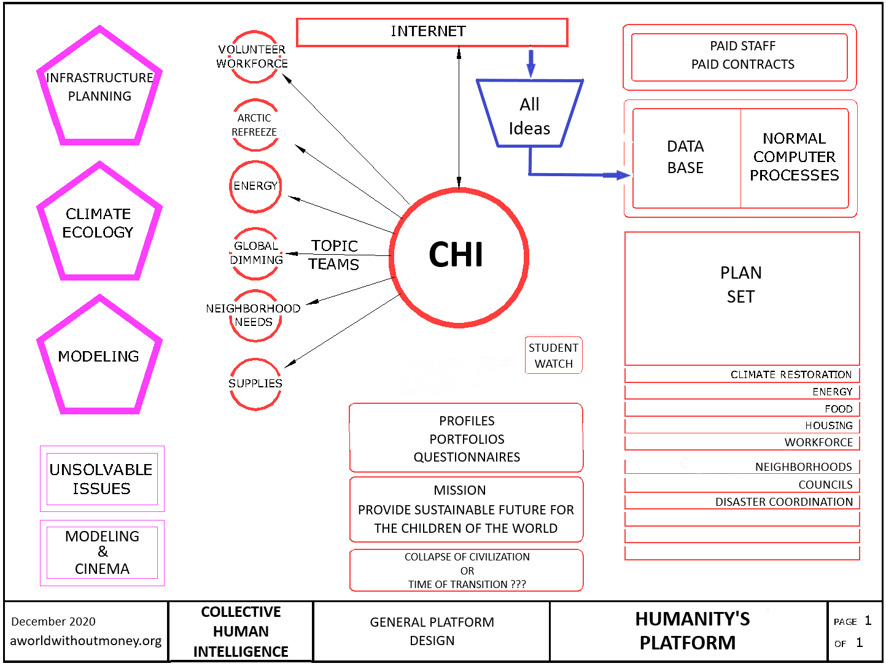

CHI - Collective Human Intelligence.

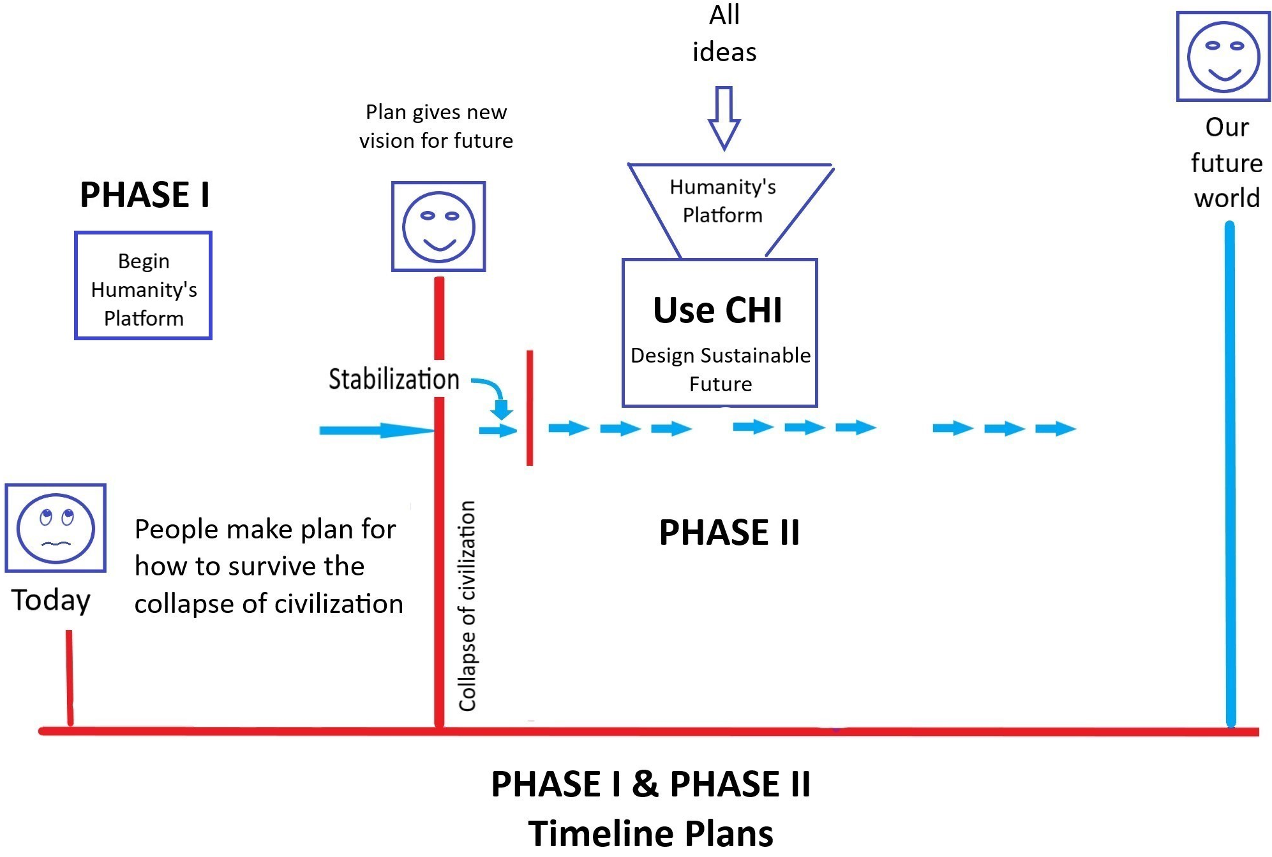

AWWM/CHI:

* Population reduction via voluntary reversible sterilization.
* Food and water are the biggest concern.

Phase 1:

Plan to survive the collapse. Phase 1 has a length of two years, or long enough to allow Phase 2 to be implemented. Development of HP (Humanity Platform).

Phase 2:

People will begin manually overturn the asphalt, restore the river, and knock down unnecessary buildings. As money is gone the minds of people will clear. Militant types of groups would be handled in manners decided by the CHI.

The author of AWWM Adam Soul is looking for 4.6 Million USD to start phase 1.

## 

## Black Lives Matter

A brutal police killing of black man George Floyd in year one quickly turned into a movement: BLM - Black Lives Matter. For several months people did demonstrate on the streets in the USA. There was some support from other countries as well. There was lots of talk about police brutality in the media, but after a few months it all went back to normal. Still the BLM movement received over 90 million dollars in donations in year one. How is that possible, how can a wild movement receive such donation? The money was actually cashed in by BLMGNF - Black Lives Matter Global Network Foundation, an organization founded in 2013. BLMGNF doesn't say where the money comes from or how it is used. There are other organizations under the BLM umbrella as well cashing in on the basis of a racial movement. Amazing how single killing by the police yields in 90+ million dollars for someone. The number of police killings in the US in year one was 1004 what is about the yearly average. The killing (murder) of George Floyd did not make any difference.

## Free World Charter

The Free World Charter (FWC www.freeworldcharter.org) wants to remove money, trade and ownership, they have published a ten item list of principles:

1. The highest concern of humanity is the combined common good of all living species and biosphere.
2. Life is precious in all its forms, and free to flourish in the combined common good.
3. Earth's natural resources are the birthright of all its inhabitants, and free to share in the combined common good.
4. Every human being is an equal part of a worldwide community of humans, and a free citizen of Earth.
5. Our community is founded on the spirit of cooperation and an understanding of nature, provided through basic education.
6. Our community provides for all its members the necessities of a healthy, fulfilling and sustainable life, freely and without obligation.
7. Our community respects the limits of nature and it's resources, ensuring minimal consumption and waste.
8. Our community derives its solutions and advances progress primarily through the application of logic and best available knowledge.
9. Our community acknowledges its duty of care and compassion for members who are unable to contribute.
10. Our community acknowledges its responsibility to maintain a diverse and sustainable biosphere for all future life to enjoy.

The FWC says it is like designing a better world from the ground up, they are not providing any details. The time has come to make some fundamental changes to our way of life, which has become both unsustainable and unjust. Adopting the principles of the FWC is the first crucial step mankind must now take in order to protect and preserve both ourselves and our planet. When enough people see the Charter and accept it as the next logical step in human evolution, change will come about automatically.

I am checking the signatures: displaying 59,544 signatures from all countries, signatures in the last 24 hours 0, number of days online 3657. This is sad, less than 60,000 signatures total in ten years. It is not possible to donate to FWC, but on their website it is possible to become a patreon of "freeworlder" (Colin R Turner). Right now the freeworlder is receiving 86 EUR monthly from 16 patrons.

## Earth Charter

The Earth Charter is a document with sixteen principles powering a global movement. Together, we are turning conscience into action for a thriving Earth. We know you're ready. Now, let's get to work.

This is the footnote from Earth Charter's website. The charter was written as follow-up to the 1992 Earth Summit. In the preamble it says that we stand at a critical moment in Earth's history, a time when humanity must choose its future.

The principles:

1. Respect Earth and life in all its diversity.
2. Care for the community of life with understanding, compassion, and love.
3. Build democratic societies that are just, participatory, sustainable, and peaceful.
4. Secure Earth's bounty and beauty for present and future generations.
5. Protect and restore the integrity of Earth's ecological systems, with special concern for biological diversity and the natural processes that sustain life.
6. Prevent harm as the best method of environmental protection and, when knowledge is limited, apply a precautionary approach.
7. Adopt patterns of production, consumption, and reproduction that safeguard Earth's regenerative capacities, human rights, and community well-being.
8. Advance the study of ecological sustainability and promote the open exchange and wide application of the knowledge acquired.
9. Eradicate poverty as an ethical, social, and environmental imperative.
10. Ensure that economic activities and institutions at all levels to promote human development in an equitable and sustainable manner.
11. Affirm gender equality and equity as prerequisites to sustainable development and ensure universal access to education, health care, and economic opportunity.
12. Uphold the right of all, without discrimination, to a natural and social environment supportive of human dignity, bodily health, and spiritual well-being, with special attention to the rights of indigenous peoples and minorities.
13. Strengthen democratic institutions at all levels, and provide transparency and accountability in governance, inclusive participation in decision making, and access to justice.
14. Integrate into formal education and life-long learning the knowledge, values, and skills needed for a sustainable way of life.
15. Treat all living beings with respect and consideration.
16. Promote a culture of tolerance, nonviolence, and peace.

It took 5000 people and nearly 10 years to produce this nice four pages long PDF document.

This document has been translated into many languages including pidgin english. A copy of the document has been placed into Ark of Hope ([www.arkofhope.org](http://www.arkofhope.org)).

And what has changed in the 20 years since this document was drafted? The only thing that has happened is that pretty much everything is worse than it was 20 years ago. Well something else has happened: The Earth Charter Initiative and the logo are now trademarks of a New York based company. You can donate with a credit card or wire your money directly to Costa Rica.

## 

## Intelligent Design

[Intelligent Design Movement](https://en.wikipedia.org/wiki/Intelligent_design_movement) is a religious campaign promoting the idea of [intelligent design](https://en.wikipedia.org/wiki/Intelligent_design) (ID). They basically say that life is too complex for undirected evolution only. As one example they bring this:

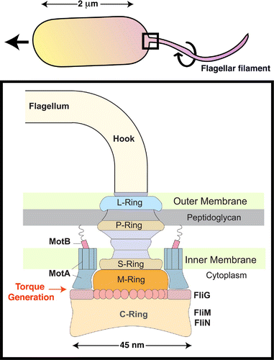

This is a rotary bacterial flagellar motor ([BFM](https://www.tandfonline.com/doi/full/10.1080/23746149.2017.1289120)) found in some bacteria. To function it needs an interaction of about 30 different proteins. The motor is rotating with speeds up to 100,000 RPM (revolutions per minute). BFM converts free energy in transmembrane electrochemical gradients into mechanical work. BFM operates at near 100% efficiency and can propel the bacteria up to 100 body lengths per second. So the ID folks say that this motor did not evolve but was CREATED by some intelligence. As another example DNA is claimed to be too complex for evolution. So the ID claims that they have found evidence of “design” in the DNA sequence.

When [SETI](https://www.seti.org/) was actively searching for extraterrestrial life in the captured radio signals I did think that well, we could also try to find it in the DNA. It is not to be excluded 100% so there could be a DNA sequence that would be impossible without being designed. But so far it has not been found. The ID folks just say that DNA is too complex.

## 

## letusbe.one

SOFT SYSTEM RESET: from the market economy to the thanks economy. The website ([letusbe.one](https://letusbe.one/)) says that we could get rid of money now/soon: Nothing bad happens if all the money in the world is gone. Nothing is taken away from anyone because then you get everything for free. They propose a third alternative:

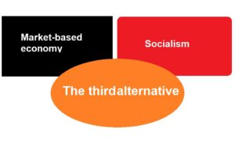

Property ownership remains, just no money.

Money has to abolished because:

* Because a climate catastrophe threatens if something does not change quickly.
* All major economic crises have been caused by money.
* Because there is need, just because people have no money although there is enough of everything.
* Because we have lost the center of our life.
* Because the gap between rich and poor is widening.
* Because the evaluation of our “Time” is very contradictory.
* Because we are on the step into a new age.

So in this new world:

* Money, Gold, etc. => 0, no value
* Property exists but => 0, no value
* Lease and rent => 0
* Credit, debt => do not exist

We would still go to work, but we would work without pay. As we get everything for free everything still works. How to get there? After a global referendum a deadline is set on which all money in the world is devalued to zero. All people are called to change their behaviour regarding work and consumption. Agreements and contracts remain valid.

What would actually happen?

* Some people start to “collect” things excessively.
* Some people would refuse to go to work.
* Some people would start travelling the world.
* All luxury items, high tech and expensive items will be “sold out” permanently.
* People including children would consume more alcohol.
* People including children would consume more tobacco products.
* Some countries will order new weapons and equipment for their army.
* Gun ownership will increase in some countries.
* Homeless people will move into Ritz Carlton and eat and drink there, they will work as much as they did before that is not at all.

What happens later?

* Military will gradually disappear as there is no need for it.
* Global spending will drop.
* Alcohol production and usage will drop dramatically.
* Tobacco production and usage will drop dramatically.
* Usage of hard drugs will drop dramatically.
* Crime rates go down.
* Number of people in jail will drop.
* Government spending will drop.
* Advertising will shrink dramatically.
* End of slavery.
* End of child work.
* End of deforestation.
* Everything is going to be better? Really?

From the website: It is a great adventure for all humanity. A departure into a new dimension of society, comparable to Mars mission.

Mars mission? That's definitely doable, it just costs a lot, and return flight may not be guaranteed.

Getting rid of money? Cost: nothing. The day will come when we don't need money the way we use it today. That day is coming closer and closer, but there is still a long path ahead.

## New World Order

In March year two the Pope Francis did give a long interview (titled: God and the World to Come) that is also published as a book in italian language. In this interview the Pope calls for a New World Order, saying that after the pandemics it is not possible to continue as before. Pope says: if we don't take immediate care of earth then our common home will throw us out of the window. The world needs to be healed from speculative mentality, reducing the gap between those who have access to credit and those who do not. The New World Order should eradicate inequalities. With a Great Reset we should shift away from fossil fuels and military spending toward a green economy based on inclusiveness. Christians and people of good will should choose which enterprises to support based on four criteria: inclusion of the excluded, promotion of the least, the common good, and care of Creation.

Dear Pope, you can't establish "New World Order" with an interview and italian language book. It is nice to see that you have also grasped that we can't continue any more on the old path. You even allow the "people of good will" to be part of your new world, not only christians. Well you know, the world is full of good people. And all of them deserve a better life on our common planet. You are dividing the world between christians, "people of good will" and others. What about the others? Don't they deserve a full life also?

We are building our new World where we all have to live together. Your book is not changing that world much. We need more. We need a new Bible. A new manual for us humans. All existing manuals (holy books) are completely outdated and don't help us anymore.

## Open Access Economy

Promoted by Colin R. Turner.

Sharing is the path to the money-free world. As we cannot share what we don't have, no-one is expecting miracles from us. We can share skills, knowledge and anything we no longer use. With some time and dedication we can get the ball rolling now. We don't need to wait for a miracle. We are the ones we've been waiting for.

Sounds good? What comes next? If you did read it online then next is patreon donation button for mr. Turner to support his work.

If a monkey hoarded more bananas than it could eat, while most of the others starved, scientists would study that monkey. When humans do it, we put them on the cover of Forbes.

Ten most shocking facts about society that we accept as normal:

1. We divide our common planet into small sections, then fight over who owns which section.
2. We send children to school for their entire childhood to learn facts and skills that most of them will never use.
3. There are thousands of religions in the world - each one believing that their one is right and all others are wrong.
4. An inventor can invent something really useful then forcibly prevent other people from using it.
5. We abuse and kill over 100 million animals every day for food even though we can get our nutrition in other ways.
6. We prioritize money and the economy over clean air, water and food quality.
7. We call some people soldiers which makes it OK for them to kill other people.
8. Everyone wants to save the planet but no-one wants to talk about consuming less.
9. We see compassion as a sign of weakness even though it's essential to our existence and wellbeing.
10. We use an economic system that facilitates the death of millions of people every year.

Those 10 facts are from a video made by Colin Turner on his youtube channel versavice.tv that has less than 3000 subscribers. Colin is also providing a [simple economics](https://www.youtube.com/watch?v=qaASCnKNTmA) simulation model (modified from NetLogo example), with this very simple model, the results when tracking wealth come always to few rich with others at poverty level (top 7% accumulataed 98% of wealth). When running the simulation with the track “energy” option all agents get better, wealth is shared equally, there are no rich and poor.

## Pay it forward

## Plant for the Planet

This movement was initiated by 9 year old Felix in Germany in 2007. The initial goal was to motivate children to plant 1 million trees in every country. The foundation has later set a mission goal to plant 1000 billion trees. There are over 88,000 children involved. There are a total 3000 billion trees on earth and there is a place for 1000 billion more. How realistic is the 1000 billion tree goal? On the official website there are projects listed with a donation button. Each project has set a price for a single planted tree, it varies from 1 to 15 Dollars. Taking 3 Dollars as low average we get to 3000 billion Dollars of donations needed. Dividing by the number of people we get 400 Dollar donations needed from everyone on earth including children and babies. Would you donate 400 Dollars to save our planet? This is a tough question. If one single donation could really stop global warming and save our climate, well I would instantly donate say 10,000 USD. Let's assume the foundation succeeds in collecting 3000 billion Dollars, will they be able to plant 1000 billion trees? China has planted 60 billion trees in about 40 years as part of the China Green Wall. The process of planting trees can not be ramped up very quickly, to plant a tree we need the tree first, it takes years. And then it takes 20+ years for the tree to grow and start consuming co2. And we need free land for the new trees. And at the current rate there are 40 billion trees cut every year, so in 25 years we would have 1000 billion trees less than today. So succeeding in planting 1000 billion trees we would only keep the amount of trees we have today. The problem our planet has is big, but it isn't to be solved by the Plant for the Planet foundation. Sorry Felix! And yes, keep on going! Every tree counts.

## Random Act of Kindness

## Sharebay

Sharebay (formerly freeworlder.com) should be a platform for sharing and giving, linking together people who are in need to those who can give something. The creator Colin R. Turner says on his patreon page that sharebay is his most important work, as it promises a way of showing that a moneyless economy can work - even in a monetary one.

A quick check: I could get a mechanic wrist watch as a loaner or borrow a kayak in australia. And what are people looking for? Colin Turner is seeking video editing software that should be not older than 7 years. Some other requests:

* A hug
* A car
* Rats for my python
* 10 tons of sand
* Readers (it's my first book)

The book the author is looking for to be read is over 4 years old and has a "you set a price" tag at some ebook promotion website.

As of today sharebay is not much functional, there are just not enough users. To really work sharebay should have more users than ebay, then it would really make sense.

The idea behind sharebay is a good one, and this service is really needed. We all have things we are not using and would gladly give away, it just isn't that easy to give. One day sooner or later a sharebay like service will take off.

## WSWS

As long as a handful of billionaires dominate society, with every aspect of economic life geared to their personal enrichment, not a single social problem - including climate change - can be solved.

# 

# Varia



I don't know what I wanted to write here, but this image has been here for ages so I leave it here.

## God @twitter

There are two Twitter users with the handle: God.

One of them is @thegoodgodabove, this account is following one and has 500K followers. The bio reads: "The best God ever, PERIOD!", location is set to heaven. This account is promoting its podcast that makes money using Patreon.

The other is @TheTweetOfGod, this account is also following one but has over 6M followers. This account is promoting a webshop.

Both accounts tweet sometimes like a God, but most of their tweets are actually rubbish. In any case, making a new "God" account on Twitter isn't gonna work out.

When you search Twitter for God you will also get Seth Godin returned in the response. He is promoting his blog on Twitter. From his blog:

The most important blog post.

It is on the most important blog.

Yours.

Even if no one but you reads it. The blog you write each day is the blog you need the most. It's a compass and a mirror, a chance to put a stake in the ground and refine your thoughts.

And the most important post? The one you'll write tomorrow.

It's the last day of year one. I'm writing. Let's make a blog post too! Done, posted a blog post on my blog! Let's make a tweet too! Done! And if my tweet gets no likes, then so what! I had to do it. And I did. And I keep writing.

## 

## tell me what you do believe in

This was a tweet on 2nd January year two. The best response with more than 800 likes:

"I'm not atheist, I'm not agnostic, and I believe religion is the major cause of most of the world's problems, and therefore I want no part of any of it."

This tweet sums it up very nicely. Religion is bad. It's that simple. Is it? Is it that simple? Time to think. Yes, it is. A world without religion living in harmony with mother nature would for sure be a better place to live.

Some other responses:

* I believe in the family... Evangelical heaven is absolute hell.
* True goodness of the heart.
* The only true religion is empathy and compassion.
* I believe in just not being an asshole.
* Anything is possible.
* Religion is a dangerous man-made competition for money and power, it is the cause of nearly every war mankind has endured.
* I believe in kindness and reason.
* I believe you should do as much good as you can and cause as little damage as possible.
* I believe we are here for a finite time, so make the most of it now.
* Unconditional love.

Another tweet has a pic of Colin Kaepernick with text:

Believe in something.

Even if it means sacrificing everything.

At the bottom (Nike logo) Just Do It.

Ah! This slogan (Just Do It) is over 30 years old!

I think I had a t-shirt with it about 30 years ago…

and I still haven't done it. But I'm not giving up.

## #godisajoke

A tweet with this hashtag had a picture with the following text:

* I created man and woman with original sin
* Then I destroyed most of them for sinning
* Then I impregnated a woman with myself as her child, so that I could be born
* Later, I will kill myself as a sacrifice to myself to save all of you from the sin I gave you in the first place

This is of course one way to explain the bible. But God and faith in God are not a joke, it's pretty damn serious.

## Favorite Movies

My list of movies:

1. African Queen, Humphrey Bogart, Katherine Hepburn
2. Gran Torino, Clint Eastwood
3. The Last Castle, Robert Redford

* Men of War, Dolph Lundgren
* Leon, Jean Reno
* Wasabi, Jean Reno
* Rio Bravo, John Wayne
* Rambo I, Silvester Stallone
* Cliffhanger, Silvester Stallone
* Joe Vs Volcano, Tom Hanks, Meg Ryan
* The Fifth Element, Bruce Willis
* The Day After Tomorrow, Dennis Quaid
* Zorro, Alain Delon

## Good Books

It is amazingly hard to find good books. This is my current shortlist:

1. The Day of the Triffids, John Windham
2. Kontiki, Thor Heyerdahl
3. Pippi Longstocking

* Brave New World

I am not sure about Brave New World, well it is a good book, there is a lot of very interesting stuff in there, and I am really glad that I got this book, this happened by true accident - I did see it on the table in the office next to mine. This book was sent to us free of charge by the author because it includes a picture of some device I have designed.

## 

## Giving away or selling?

I have had a pretty expensive machine (paid 13500 EUR for it) laying around useless for many, many years. So one day I tweeted:

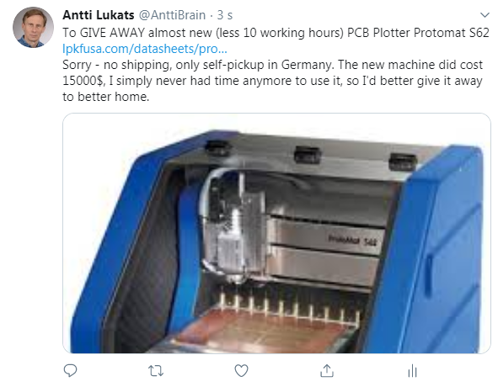

I got pretty little feedback, one was:

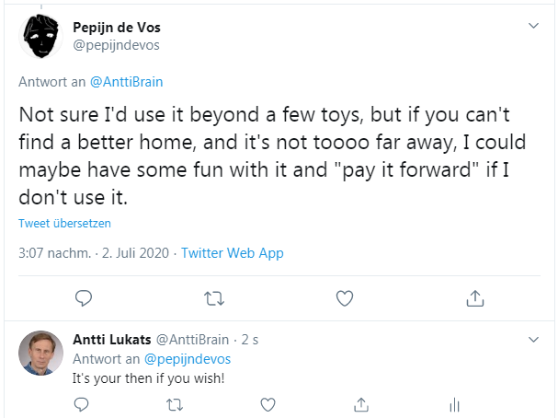

I would have given the machine for free, but then the next day after the tweet I got an 800 EUR offer for the machine. So I sold it back to the manufacturer LPKF. It’s gone. Sorry folks, 800 EUR is more than nothing. The reason why I did sell it back to the manufacturer instead of giving it away was missing software, I did not want to give away a machine that could be useless. Now it for sure finds a new owner. At least it does not collect dust anymore.

We should give away things we do not need anymore. Sometimes it just ain't that easy.

## Guide to Living Longer

From Dr. Shigeaki Hinohara (via Medium) who lived 105 years old and worked until the last months of his life.

Short version: To live longer give yourself a reason to live.

Medium version: Fun is the best painkiller and laughter is the best medicine. Don’t place too much importance on material possessions. Carry your shopping and use the stairs. Try not to overeat. Don’t opt for surgery first. The purpose is most important - keep on livin’. If you must retire, do it well over 65.

## 13B$

In year one there was a day when the net worth of the world’s richest man (Jeff Bezos) increased during one day by 13 Billion US dollars (13,000,000,000 USD). It’s almost like there are suddenly 13B$ dollars in your bank account. What did Jeff do with that extra money? He could have used it to-do lots of good things. Did He? Possible not. He was just a bit richer. And still divorced.

What would you do with 13B$? What would I do? First I would send 1M$ to Don McKenzie as I once promised that he would also be a millionaire should I become one. That’s the easy part. What should I do with the rest?

Option 1: I’d buy flowers and say to my wife: “Darling I have a problem that I wish you to take care of for me. All this money - please manage it!”. This would be an easy way for me. Just give up all responsibility for all that money so I can’t do any silly things with it.

Option 2: I would:

1. Buy a new bicycle for my wife
2. Buy a new bicycle for me
3. Buy Braun Series 9 shaver for me
4. Reserve 5B$ for the family (not to ever be used by myself)
5. Reserve 1B$ for “emergency use” (when all money has run out..)
6. Reserve 1B$ for miscellaneous donations
7. Reserve 3B$ for the “Saving World” Foundation (to be founded..)
8. Reserve 1B$ for my ideas (play money)
9. Reserve 1B$ for my wife ideas (play money)
10. Reserve 100M$ for running household use
11. Reserve 100M$ for the development of a multi-platform mobile game: “Saving World”
12. Reserve 100M$ to fulfill most of the tasks from my “Warren Buffet” 5/25 task list
13. Reserve 10M$ to sort out my “past life” - all projects from old hard disks…
14. Reserve 1M$ for my friend to manage the internet domains I own...
15. The remaining funds would be allocated for other usages as needed

Option 3: I would:

1. Buy a new bicycle for my wife
2. Buy a new bicycle for me
3. Buy Braun Series 9 shaver for me
4. Reserve ?B$ for the family (not to ever be used by myself)
5. ????

Option 4: I would:

1. Buy a new bicycle for my wife
2. Buy a new bicycle for me
3. Buy Braun Series 9 shaver for me
4. Buy flowers and talk to my wife…

What would you do with 13B$? What’s on your list? When I compiled my options I realized that all of the options included new bicycles and a new electric razor. Things that I can just buy now. And flowers for my wife. There isn’t much in the world I would love to-do alone without my family. I have been all around the world. I have done lots of technical things in my professional life. Doing something technically challenging isn’t a challenge for me anymore - I have mastered too many challenges already.

After writing the above option-lists I got a notification that the sale of some real estate (house + some land) was successful and the sale price was 15K EUR above the start price. So I kind of got 15K EUR extra money today. This is the most “extra money” in my life. Sure it’s one million times smaller than the amount Jeff earned in one day but it still feels good.

So what about tonight? I guess I go buy flowers and Braun Series 9 Shaver!

Flowers - Done!

Braun Series 9 - Done!

What about bikes? Still pending as the bike my wife wants can not be ordered, we have to wait.

## 

## I finally said it!

I have been writing for some while already but failed to say to my wife and children that l have writing as my hobby. Somehow l was so afraid to say that l am writing a book. Today l finally said it, to my wife and daughter also. Feels good. It wasn't that hard at the end. But sometimes very small things are very hard for me. Talked to my son too, he is also trying to write some short stories considering webnovel as a publishing platform. Writing a novel or a book isn't easy, that's why I am writing a Bible.

## Knitting Wife

I once started with a picture book titled "Knitting Wife". I just did use photos from the knitting of my wife with very short descriptions. Sometimes I think I should have continued with it. There are so many amazing things she has created. It's just incredible. I should scan old backup disc drives, maybe I still have a copy of this book. But it can be that it is lost as my notebook was once stolen. I wish I would have stored a copy online. Sure I can make new photos from some recent works of her but it would not be the same as some works are not available anymore. Short test - how many knitted things can I see from my current location on the couch? I look left, I look right - the count is 18!

## 

## 5000 Dollars

I am lying in the hospital bed when suddenly the man in the next bed starts to yell: “Help, help”! There is blood coming from his stomach, the man is crying for help. I had been in the bed after the operation and not yet walked, so I did hesitate a few seconds, then I took my two “bags”, put them into my pockets, and went searching for a nurse. Later when I talk to the young man, he says that he was in the hospital to sell his kidney for 5000 USD. But the analysis was not okay and his kidney was not accepted. He said he is happy that he got to keep the kidney. For sure he possibly faces problems when going home without money. This happened in Tallinn, Estonia. Things like that hopefully are not anymore happening in Estonia, but worldwide the sale of human organs (from live donors) is pretty much happening, mostly in China and other Asian countries. They also keep humans alive in prison until the organ is needed and kill when the transplant is happening.

## 155 EUR

At the airport in Zürich, there is 155 EUR cash in my pocket. I got it from a rather old man; it was all the money he had. He was far away from home without a smartphone, without a credit card, with his prepaid mobile credit empty. How did it happen? Why did I take his last money? I did not need that cash from him, and still, I did take it. The cash in my pocket proves it.

It started at about 0615 in the morning in Zrece, Slovenia. I had been walking around since 0430 killing time hunting Pokémon. The shared ride to the airport I had arranged was supposed to pick me up at 0700. So while walking around l met that old man, he had only one very small sports bag. I asked what he was doing. I want to get to the airport, but as today is Sunday there are no buses, so I hope some car will go by and take me - was his answer. I explain that I am waiting for a shared ride and that hopefully there will be a free seat for him too. I call the shared-ride driver asking if he can take one more passenger, he says he will call the central and ask about the payment. As we wait we go to a cafe close by that opens at 0630. The cafe only serves drinks, there is no food at all, I order coffee for myself and tea for the old man. The total is 02.15 EUR l pay for it. When we sit down the old man takes a candy bar from his bag and cuts it into half offering it to me. His name is Alex. I talk with the driver again, he confirms that there are free seats and that it is possible to pay directly in cash. So Alex will get at least to the airport. In the van on the way to the airport, we talk all the two hours of the ride. Alex was also at the same ARDF competition in Rogla as I, representing Kazakhstan as a one-man team. Alex is Russian, living in the Russian part of the country that was later connected to Kazakhstan. He says that nobody loves Russians in Kazakhstan. It's so weird, he has been representing his home country at ARDF championships for more than 30 years. He usually gets some medals. Year and year and again he is on the podium and the national anthem of Kazakhstan is playing. He is retired with a 600 EUR pension. He pays for travel and competition fees from his own pocket. For me he is Kazakhstan! Alex is 72 years old. We talk about building new fox hunt receivers, Alex tells me that he managed to buy 200 pieces of crystal filters for his receiver. My idea is different, I would do it all in the digital domain using the direct conversion method. Alex also talks about a new grand chess derivative he has been promoting, it's called princess chess. There are two additional figures: the prince and princess are added to the regular chess. Alex has patented this game. He also has over 100 sets of princess chess figures so he could even host a tournament. When we arrive at Ljubljana airport, Alex pays 10 EUR "black" to the driver. We depart and shake hands. My flight is canceled, I get a new flight and 160 EUR cashback. I have a 3 hours wait time so I'm looking for Alex. He is at the Aeroflot counter trying to change his flight from tomorrow to today. As Alex English is not very good I help out. It seems to take forever, but then finally there seems to be a success, the lady says that Alex can change the ticket if he pays 327 EUR extra. I am sure Alex will not take that offer, but Alex asks for confirmation: "If I pay, I can fly today?". Yes. Alex asks me to wait and runs towards passport control where he hopes to catch some friends from the Russian team to borrow some money. Soon he was back, his friends had already passed by. I have 155 EUR, says Alex. Well I had my credit card in my hands already - please charge this card! I pay for Alex’s upgrade. And when he gives me that 155 EUR I take it all, not realizing that it was really all the money he had. When we say goodbye Alex says: "You are sent by God! Twice today!" We had agreed that Alex would payback next year at the next championship. But the competition is canceled due to coronavirus so Alex pays back via wire transfer. It was his wish, I didn't ask for the wire transfer.

Alex contacted me later with a plea to help him to contact a person in germany per email, he wants a GUI to be developed for princess chess. He had already managed to have the princess chess game engine being developed for him, so he wanted me to contact a german author of some GUl with a plea to adapt the GUI for the use with princess chess. I wrote that email but failed to get a response. So I failed to help Alex. I did some research, and found some open source source code for chess GUI, so the task should not be that difficult to adapt it to princess chess. I could do it, technically it's not complex at all. I could do it should l have sufficient worry free free time.

## Bruce Lee

One day on my way home from the fitness studio while passing the three pillar fountain close to home I met Bruce Lee. He looked very happy and started to talk about his luck as he had just got a 100% legendary pokemon. Bruce Lee is a Pokemon Go nickname of a young boy who usually plays together with his father. I have talked to them once for a few minutes maybe 3 years ago. But they still recognized me. It was a nice feeling to talk to Bruce Lee again! I left them with a smile and good wishes.

## Care for a game of chess?

In the hospital, there is an old man who has 6 plastic tubes coming out of his body with plastic bags. Then he stands up, collects the plastic bags into the pockets, and comes over to my bed. "You play chess?" he asks. Yes, I grab my two bags and we go together to the club room. During the first game, I suddenly realized that I am afraid to play. Afraid of that old man. And it's just a game. It's just a game. Realized that I started to play without fear, and I played better. I still lost the game, but I lost fighting. I did win the second game, maybe he did let me win or maybe he was just tired. But that feeling of not being afraid - it was great. We can all play better without fear. We are simply better without fear. There is nothing to be afraid of - not in the game and not in real life.

## 

## Decision Courage

When I was young I did think that any man who has nothing above one word for his son is a good father. That one word I had on my mind is "Decision Courage" (it is one word in Estonian: otsustusjulgus). At that time I was building model rockets in the local club. The teacher was a young guy maybe 20 years old, he said once to me: "I am not a good person, I smoke, I drink and I talk dirty". He did smoke, yes, even when we made the gunpowder for rocket engines, but I never did see him drunk. His worst cursing word was: decision-courage-less (otsustusvõimetu). I did build lots of different rockets and participated in many contests with them. You really can not build a rocket if you can not make up your mind. If you have decision courage you can master anything in your life.

## 

## Infinitely Loved

One day on the main square a young couple approaches me: “Do you know you are infinitely loved?” the man asks. I am puzzled: “!?”. “Do you know you are infinitely loved?” he asks again. Now I am getting it slowly, they must be from some religious sect trying to sell me their faith! Well, they are very polite and I take a shopping card chip they are handing to me. On the chip it reads: “infinitely loved” (**unenendlichgeliebt** in german) on one side with an URL on the other side. I planned to check out the website but I lost the chip! Out of curiosity, I am trying an URL using ‘unendlich geliebt’ with a german top-level domain ([unendlichgeliebt.de](http://unendlichgeliebt.de)), and indeed there is a website at that address! It belongs to a young woman named Mandy who is posting her blogs. The blogs all include some reference to God and/or the Bible. So the chip is pretty much an advertisement for a religious blogger website. This is how this chip looks like:



If you click then it comes a feedback form asking info about the place where you found the chip. It is also possible to buy those chips (for those who want to distribute them), the minimum order is 50 pieces for 3 EUR (5 EUR with shipping). On the website it is also possible to donate to Mandy and she has a link to her Amazon wish-list as well.

One example from Mandy’s blog:

“Sexuality is a genius gift from God, 98% of men and 78% of women masturbate.”

Actually, Mandy’s blog posts are not that bad, but you have to strip out the God and Bible parts from them.

## A Friend

In year two Linkedin sent me a notice that I should congratulate my friend Andrey on his second work anniversary at Apple. Dear Linkedin, Andrey is dead for almost two years!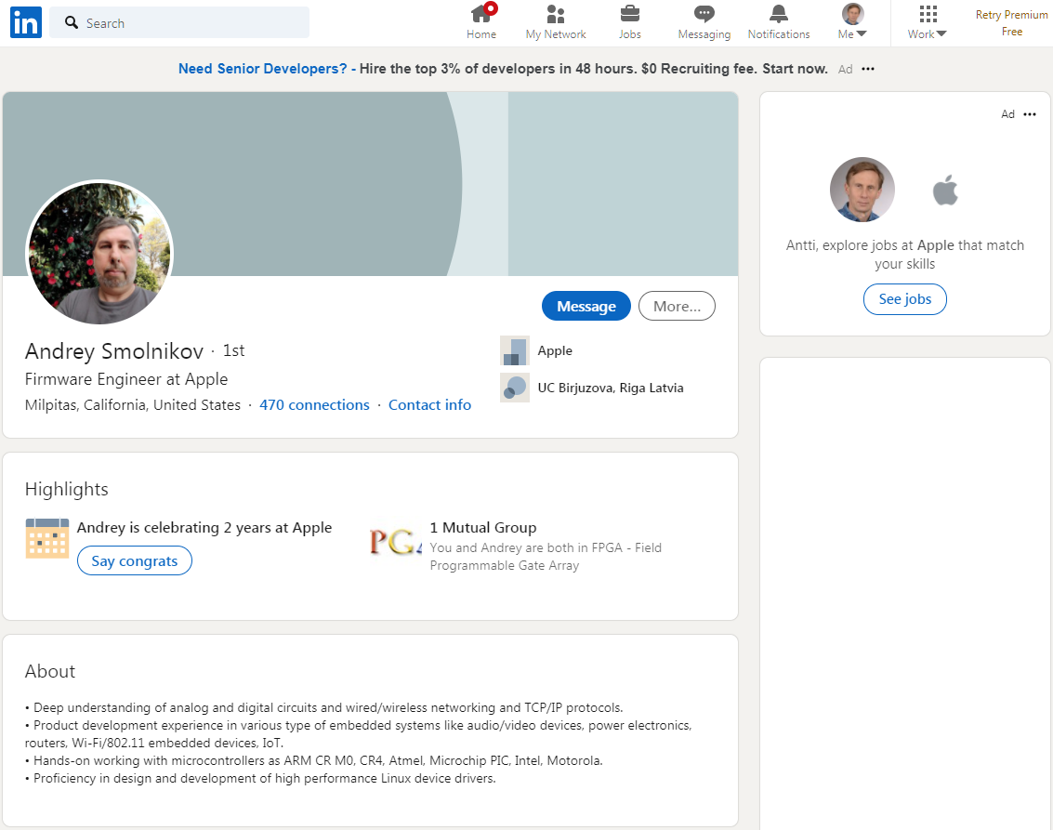

The first time I visited the USA I was asked if I want to have a conversation with Steve Jobs.

I was too timid and said no. Really, a true story.

I have never worked for Apple. You did, but you are dead now. A lost friend.

I met Andrey many times in his home town Riga where he did live with his parents. The second WC in that apartment was converted to his Electronics Lab. It was really just a tiny closet where Andrey did work and solder his electronics gadgets. Andrey was eager to explore the exciting world of electronics and he was happy back then. He was happy.

Andrey's house in California had a small pool in the garden. Yet, in his house Andrey asked once: "How did I end up in this shithole?" He had hard times finding a job. Most of all he was worried about his daughter's tuition for the university. He said: "I could sell the house and pay the tuition, but where would I live then?" Andrey's daughter was studying to be a sea biologist. She also writes poems. Andrey did show me one. He was so proud of his daughter. And so worried. It was really emotional. It was really hard to see a friend to be so down. In the sunny California. I did think a lot about how to help Andrey. I had a house in Estonia staying empty, a place to live. I was about to say that he can live there. I never said it. When I heard that Andrey passed away I was afraid to ask how. I was afraid that maybe he killed himself out of desperation. And that I could have been more helpful. It wasn't a suicide and there was nothing I could have done. Doesn't make it any easier, losing a friend is hard.

[käbi]

Four commandments of criticism

Own your criticism, say I (I think.. in my opinion..)

Qualify your criticism, rationalize, say why

Highlight the positive, see the good

Instruct or improve, say what should

## Ideas having sex

TED talk from Matt Ridley

Change of goods. Division of work. Trade is older than farming. No single person knows how to make a computer mouse or a pencil. Shared knowledge. We created an ability to make things we don't even understand. Important for society is how cooperative we are, not how intelligent we are. We are the neurons in the collective brain. Everybody can have ideas that can meet and mate with other ideas, this is what makes progress.

Ideas having sex is what brings us forward.

## Corporatism

Poverty and bad health are breeders of desperation. The desperate have nothing to lose. Nothing is more destabilizing to civilization than desperate citizens.

Corporatism is about profit. Profit creates poverty. This is America, this is the world.

"Fascism should more appropriately be called Corporatism because it is a merger of state and corporate power."

Benito Mussolini

## No one listens to me

A blog post from Tom Osher

Short: Life is so complex and so rich, a gift so large that it is hard to appreciate it fully. Yet for billions of us, life is an ordeal that must be suffered and endured. If we keep ignoring all that bad that happens around us we soon all die. It seems so hopeless. No one listens to me.

[www.utopiacornucopia.org](http://www.utopiacornucopia.org)

Dear Tom, you never know who may listen. And it's never hopeless. Even though

Utopia Cornucopia is merely a dream right now. It is a sign that there are people who care about the future.

libcom.org

The environmental catastrophe is a product of the capitalist system of production. All solutions that leave capitalism in place are futile. We need to start producing for human needs in a globally planned way. This means revolution.

Capitalism: a world where 26 richest people own as much as the poorest 50% .

There are two primary choices in life: to accept conditions as they exist, or accept the responsibility for changing them.

Denis Waitley

anthropomass.org

Humanity is constantly manufacturing various objects, we call the mass of all of these objects "anthropogenic mass".

Year one (AD 2020) marks a crossover point when anthropogenic mass exceeds global biomass on earth. This should be pretty alerting, it means that man-made objects have more mass than all living things on our planet.

# 

# Reading and Books

*So many books and so little time*.

Frank Zappa

A good book is a tool that operates on your mind.

It may change you and the way you see the world.

But where do we get good books? We only have a limited time for reading, and there is the price issue also. Of course, a good book is worth its price. But we need to identify the good ones!

Wait a moment, wouldn't the bible be a good book to read? It should be available for free? From holybooks.com you can get 742 pages long pdf copy of the holy bible. Starting fast scan reading.

"A stubborn and rebellious son should be **stoned to death**." {Deuteronomy 21:18-21}

Please read the above line a few times. And think about it. I did. I'm speechless.

A stubborn son should be stoned to death?

What kind of book tells that? Ah, it's the bible? What comes next?

"You should not wear woolen and linen together." {Deuteronomy 22:11}

I think I'm done with bible reading for today, back to bible writing mode!

## Self-help books

I type into the search bar "self help", google autocomplete adds "books", I press enter! Feeling lucky, taking google's first hit, landing at lifehack.org on the page titled: "27 Best Self Improvement Books No Matter How Old You Are". For every book, there is a short description, and amazon links to paperback, ebook or audiobook formats (if available). Scrolling down the page, to "Final Thoughts": what next? Read them all? Ebook prices are between 10 and 20 USD, none of the books is free.

At the bottom, there is a link to a page: "How to Increase Brain Power, Boost Memory and Become 10X Smarter", click! A concept of Digital Brain? Hmm, interesting! Scrolling up and down trying to find the trick. So how? There is no advice, only a Link to a free webinar and more articles.

10X Smarter? I don't want to be any smarter, I have been too smart all my life. But at age of 55 my memory is not what it was anymore. When I was younger I had all the phone numbers in my head. Then one day I realized that my brain is not holding all the numbers for me. From that day I did write down the numbers, not relying anymore on my own memory. This is a piece of good advice for everyone: if something is important, write it down, do not rely on your memory, no matter how young you are. The best is to write it down in some place that you can easily access online like google docs.

But what about that Digital Brain? I'm back at the lifehack website clicking links. Ah here is the explanation - use digital tools like:

* Airtable
* Dropbox
* Evernote
* Google Drive
* Pocket

Oh really? That was it, the big secret! I use Google Drive a lot, sometimes I have used dropbox and I have Evernote installed on my mobile. But what are airtable and pocket? To be checked out. Starting Evernote, it says that I have a premium account, is it free? No! It seems I am paying 69.99 USD annually for the last three years! And I have not used it at all… It really is better to stick with free services whenever possible.

Back to lifehack.org main page: "Lifehack - The university of life"

Main menu - Your Current Challenge:

* Feeling Stuck in Life
* Struggling To Reach My Goals
* Lack Of Motivation
* Getting Distracted Easily
* Learning Slowly
* Too Busy To Get Fit
* Feeling A Lack of Energy

Interesting, I could say my current challenges are all of them or none of them.

… todo …

## 

## medium.com

Medium is a writing platform for short stories. There are 3 free stories to read each month. OK, there is a little trick - you can read 3 stories from any different browser and device if you do not login to your medium account. Barack Obama is one of those who write on medium. If you are registered at medium then they will send you emails with personalized daily reads. Medium stories all include a note how long it takes to read the story. Most stories are 2 to 10 minute reads. Monthly membership costs 5 USD. There it is also possible to earn money if you publish stories. I have earned some money selling ebooks so I can tell you that earning money on medium isn't easy. I have no hope that I could publish medium stories that would earn money for me. Right now I am saving my medium daily emails for reading later. I have some reading to-do…

Later… My gmail inbox has lots of medium daily mail's all waiting to be checked out. Time?

## Goodreads

This is a book lovers website, the site will give you recommendations if you have rated some number (20+) of books yourself.

## 

What genre does “Antti Bible” belong to? Ah, there is a “nonfiction” genre too. Well as the goodreads only lists commercial non-free books and ebooks it would not list a bible anyway.

## I read for you…

Many years ago I had an idea of “reading as service”. It was mostly focused on technical magazines: the reader (a person with deep domain knowledge) would read a number of magazines and write a monthly overview extracting only the essential pieces from them. So the readers of the “overview” would get all the news from several magazines, without buying the magazines or spending time reading them. The same approach could be applied to books as well of course. Most books have little content and lots of “filler” that could be skipped. Sometimes I think this service is needed now more than ever. Of course, the “reader” can not simply copy text from the magazines or books, he has to rewrite and describe what he did read. I would subscribe to such a service if it would include some magazines about electronics. The magazines are so full of unwanted advertising and the actual content seems to be decreasing, so I have pretty much stopped buying any magazines.

It appears that the newspaper "The Guardian" is already doing it for 10+ years, they have a column titled: Digested Reads where one coworker writes in about 700 words about some book. And it appears there are several books that are composed of those digested reads only. So the “I read for you” idea is already being used for profit by someone.

## How I Approach the Toughest Decisions

by Barack Obama via medium

Our choices reflect and determine who we are.

* Don't get paralyzed in the quest for a perfect solution
* Don't go with the temptation to follow your guts
* Create a sound decision-making process:
  + listen to the experts
  + follow the facts
  + consider your goals
  + weigh it all against your principles

Then, no matter how things turn out you know you did your best based on the information on hand.

When you have a tough, almost unsolvable decision to make, you don't just want people to tell you what you want to hear. Create a space to think. Even when a decision is required quickly take some time to let your thoughts marinate.

Barack Obama's mother: there are two kinds of people in the world - those who only think about themselves and tear others down to make themselves feel important, and those who think about how others feel and avoid doing things that might hurt them. Which kind of a person do you want to be? We should all answer this question.

## The Most Clever Life-Hack I've Ever Learned

This is from my medium daily read.

Fall in love with doing instead of the idea of doing.

81% of the people want to see their name on a book cover, but less than one percent sit down to write every day. We all want to improve. To succeed. To be better. And we want it right now. It's human to feel that way. It's simple but difficult to acknowledge that the best hack of all is not trying to hack anything.

Don't fight the truth. You have to earn it. You know it. I know it. Only a few, however, can embrace it.

I am not sure I got it. Or maybe I did.

Hmm… this was a simple yet difficult read. A good one. I have certainly tried too many productivity-boosting hacks and tips with little to no results.

The author of this article offers a free book, where is the trick? There seems to be a simple request form asking for email only. Ah, there is a subscription linked! Well in the email there is an unsubscribe link too so I'm sold. A few seconds later I downloaded a 65 pages ebook titled "The Destiny Formula" and unsubscribed. Checking at amazon the same book costs 16 USD in paperback and 5 USD in kindle format. Nice, now I have one more book to read...

## THE FIRST 20 HOURS

(How to Learn Anything Fast...)

by Josh Kaufman

From the back of the book: "Want to learn to paint, play the piano, launch a business, fly a plane? Then pick up this book and set aside twenty hours to go from knowing nothing to performing like a pro. That's it."

Sounds great? Right? The book has 274 pages but only 26 with actual content, the remaining pages are the author's portrait and explanation of how Josh learned to play the ukulele.

Ten principles of rapid skill acquisition

1. Choose a lovable project
2. Focus energy on one skill at a time
3. Define your target performance level
4. Deconstruct the skill into subskills
5. Obtain critical tools
6. Eliminate barriers to practice
7. Make dedicated time for practice
8. Create fast feedback loops
9. Practice by the clock in short bursts
10. Emphasize quantity and speed

Ten principles of effective learning

1. Research the skill and related topics
2. Jump in over your head
3. Identify mental models and hooks
4. Imagine the opposite of what you want
5. Talk to practitioners to set expectations
6. Eliminate distractions in your environment
7. Use spaced repetition and reinforcement for memorization
8. Create scaffolds and checklists
9. Make and test predictions
10. Honor your biology

Two times ten principles. So what is right and is it really possible to learn in 20 hours and be a pro? True is that when learning and practicing in the most effective way it is possible to acquire almost any new skill to some performance level in 20 hours. But for sure you will not be a professional in 20 hours. It depends also a little bit on the skill, I for example would be very bad on the ukulele after 20 hours. And it is for sure not possible to fly a plane like a pro with 20 hours of learning and practice. Or is it?

Flying itself is easy. It may go like this: At a small airfield, I walked towards a group of people at wind gliders, I asked: “Can I fly?” Yes, if you pay the “tow fee” of 80 Finish marks! I did get a parachute and there was a short explanation before the flight:

* Should we need to jump look which way the plane is tilt first
* When opening the parachute use both hands and make symmetrical movements to avoid spinning in the air
* When you get the steering, no rush movements and only +-15 degree movements of the steering stick

And with that intro we did take off with the wind glider. We did fly over an hour and I got to steer the plane for about 15 minutes. It felt superior, it is really cool to feel the wind in the wings. To fly in almost silence. It is an amazing feeling. Flying a plane in mid-air is simple, much simpler than driving a car actually. So learning to fly in 20 hours is possible if we do not count take-off and landing. Take off and landing are the complicated part. Unless you learn to fly with this plane:

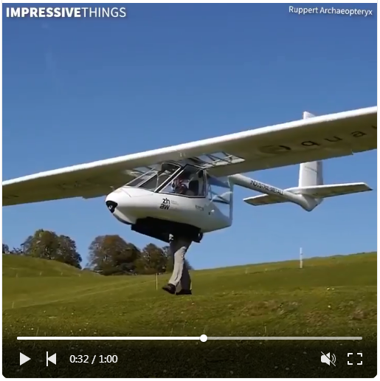

This is [Archaeopteryx](https://www.ruppert-composite.ch/en/). You take off and land on your own feet! So I’d say even learning to fly in 20 hours is possible. You still would not be a professional pilot in 20 hours but you can manage the flying itself including take off and landing.

## 

## The One Book That Will Change Your Life

This is what I did see in my Medium daily notifications:

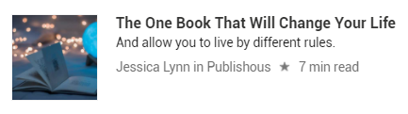

A 7 minute read about one book that changes Life? I was curious enough to spend one free Medium read for this article. Ha, this is the end of the article:

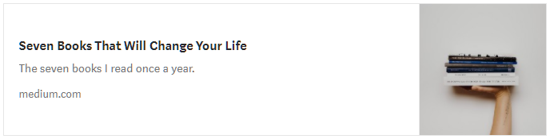

Now it is seven books? But OK let’s see what this medium article is about.

Here is that one book:

*The Four Agreements: A Practical Guide to Personal Freedom*, by don Miguel Ruiz.

And here are the four agreements:

1. **Be Impeccable With Your Word.** Speak with integrity, say only what you mean (and know). Don’t speak negatively about others or yourself.
2. **Don’t Take Anything Personally.** Others see the world with different eyes, nothing they say is really about you.
3. **Don’t Make Assumptions.** Practice healthy communication, instead of making an assumption, ask.
4. **Always Do Your Best.** Allow your best to be different at different times. Let the past go and focus on the future. Learn to say NO to the things you do not want to do.

I can’t duplicate the article here, but it was worth reading.

One of my own rules says: “All assumptions are assumed to be false” - this is the same as the 3rd agreement from the book. As soon as we assume something about something we are probably having it wrong, so it is best not to make any assumptions. We don’t know what is in other people’s heads, so it is better to ask directly and not overanalyze the situation.

In school I had it hard for a long time until I learned to not take it personally. I was bullied a lot as I got really upset when I was called names, until I learned to ignore it. I know my son doesn't have it easy as well. But I don't know how to help him. I just hope one day he realizes it as well: we should not take it personally what others say about us.

## The Book I Wrote That Saved My Life

(and I hope it can save yours too)

by Robert M. Drake

Bright yellow book cover with black text. A book that saved the author's life? A book that can save my life? Your life? Interesting… A total of 533 life saving pages. Amazon offers a look inside that reveals the first 8 pages. What is this, every line has only two to four words? And lots of empty lines? Reading.. bla-bla… bla-bla… This is of course one way to increase the page count for the book. Finally I get it, this is supposed to be poetry! Did writing that book save Robert's life? Does the book tell how it did it? Somehow I doubt it.

Is your life in the need to be saved? I do not know. But for sure writing a book would save your life should it be in the need of saving. Writing of any book, be it poetry or not could save a life. Your life. It doesn't matter if you finish it. It doesn't matter if you publish it. Writing it matters. You think you can't write a book? Have you ever tried? And maybe it's a photo book you want to create? Go out in the world and make some snapshots. The important thing? Stay alive for tomorrow so you can keep on writing. Stay alive and keep on going.

## Planets survival

From The Guardian

Capitalism is on a collision course with human life and the future of the planet. The USA is an oligarchy rather than a democracy. Organised wealthy interest groups have a powerful impact on government policy; ordinary citizens have not. Top 100 companies are responsible for 71% of global greenhouse gas emissions, while the poorest half of humanity are responsible for just 10% of global emissions. Top 26 richest people own as much as the poorest half of humanity. Capitalism, at its core, requires a workforce of poor people or slaves to do back- and brain-breaking labor to maintain the wealth of those at the top.

## Mars colonization

Elon Musk, world richest person, is selling all his possessions so people know he's serious about colonizing Mars. He has plans to send as much as 1 million people to Mars by 2050. Musk will offer loans for those with no money to be paid back with work on Mars. So those who are poor on earth would be poor on Mars as well.

## Hope in Hell

(A decade to confront the climate emergency)

A book by Jonathan Porritt

… a roadmap, a bible and a manual all in one … It should be read aloud in every classroom, university and home.

Radical transformation, including civil disobedience - last chance to avoid climate-driven societal collapse.

… one of the most important books any of us may read.

Dear Jonathan, if your book is all of what the reviews say, if it really is as good - why don't you make a ebook version free of charge so everyone in every classroom and home could read it? You know reading your book could make a difference. But not at the price of 17 UK pounds. At that price it's only good for your pocket and not for the community.

## You Need This Book to Get What You Want

By Mark Palmer, Scott Solder

Really? The title sounds challenging. Searching for reviews and voila this time Guardians digested read includes its own digest at the very end: “Like a hole in the head”. Checking out other reviews: interesting one goodreads review also mentions “A hole in the head”! Can a book be that bad? Why not. But it still gets published and is sold as well.

## When God would be real...

I got this small book (german title: "Wenn Gott wirklich wäre ...") free of charge one day while walking on the main street.

From the book: An educated man comes to Jesus for advice, Jesus says: “Love God and one another”. Well as God is not real, we can shorten the sentence to: “Love one another”. This is really good advice.

From the book: The Bible is God's user manual for humans. Again as God is not real we can simply say that: “Bible is user manual for humans”. Nothing more nothing less, just a user manual. An outdated and overly complicated user manual. We should not read outdated manuals!

Each chapter of the book did begin with: “When God would be real… <then something>”. Only at the end of the book, the author said that he firmly believes that God exists and that the Bible is the word of God. Let's think a bit...

When God would be real… how old would God be?

Choices:

* 6000+ years
* 100,000+ years
* 5,000,000+ years
* About the same age as Big Bang
* Older than Big Bang

If we look at the choices we see that there is no plausible age for God! So the only choice possible for God’s age is void - God isn't real and hence has no age.

When God would be real… does God eat and drink?

Where do the food and fresh water come from? Who prepares the food? If God would eat and drink he would also shit and pee? So God goes to WC? No? So God just shits on the ground? No, it must be that God doesn't eat or drink. So God also has no sense of taste of food. God doesn't make a difference between water and wine? No, the answer is that God isn't real.

When God would be real… does God breathe?

Where does the fresh air come from? Where goes the co2? How is the air pressure maintained? Too many questions with a simple answer: God doesn't breathe or depend on air pressure. So God has no use for the lungs and nose. God doesn't have a sense of smell. God can not speak, sing or make audible sounds. No? Yes, God is'nt real solves problems here too.

When God would be real… would he be happy now?

When God looks down he most likely would be very unhappy seeing what humans are doing to the planet earth. What would an unhappy God do? Not sure but God would certainly do something! He would do something to end the madness on earth. But as God isn't real the madness just goes on.

When God would be real… was he ever young?

God is always described as old, grown-up, but has he ever been young? How can it be that God has always been old? He must have been young too. But what did God do when he was young? Did he play and learn? Play with what? How did he learn? Did he learn from mediation only? When did he gather the knowledge of how to create the universe?

When God would be real… is he also alive?

Choices:

* Yes, God is alive
* God is dead (but was alive before)
* God exists but is not alive
* God is a machine
* God is not singular
* God is a Trinity
* God is everywhere

From the biological point of view it is hard to say if God is alive as God doesn't reproduce by having sex or other means that include DNA transfer. And at least the Holy Spirit as one-third part of the Trinity is not alive. So God as Trinity is at least one third dead.

When God would be real… is then the Bible word of God?

Well if God would be real he would not allow the Bible (or any other holy book) to be as un-precise as it is. The Bible is written by humans to be used as an instrument of power. The same is true for any other holy book. The Bible and other holy books are powerful and dangerous tools that have been used to do lots of evil things in the name of God. But the holy books are not the word of God, they are just books written by some people.

When God would be real… which God would it be?

There are many religions in the world all describing different Gods. Can it be that all those Gods are real? No, for sure some of them or at least one of them is not real. Now if we select one God out of them we can always say that this is the one God that is not real. And we can do that randomly picking the Gods until we have excluded all of them. None of the Gods is real. They all exist in the minds of the believers only.

When God would be real… where is he?

Choices:

* On earth, hiding
* In the heaven
* In a spaceship far away
* In 4th dimension
* In an alternative universe
* Everywhere

Whatever we choose, God is and remains invisible and undetectable. There really isn't a place for God to be in, except in the minds of the believers only.

When God would be real.. does heaven exist?

If heaven exists its population would increase all the time. So heaven itself should also be ever-increasing in size. The current estimated population of heaven is over 10,000,000,000 souls. The human brain consumes about 10 watts, if we count with that value we get heaven's power consumption to be at least 100 gigawatts to activate all the souls. Where does this energy come from?

When we get to heaven what will we do there? Can you imagine one thing you (your soul) would love to do in heaven? Bear in mind that you will be in heaven forever. What will you do to kill boredom? Sing? Dance? Be merry? Forever? Observe the people on earth doing bad things? Wait for the loved ones to die to see them? Whatever you do in heaven you can't help the living ones on earth in any way. You can only observe, well if God allows it. Knowing that none of your actions can help those living on earth? Would you be happy? Eternal life in heaven, not being able to change anything. Sounds like pure hell.

When God would be real… does hell exist too?

The ever increasing population of hell would be at least 5x bigger than that of heaven, so over 50,000,000,000 souls. So hell needs more than 500 gigawatts to activate all the souls. And the Devil is forced to accept all souls rejected to heaven. So to hell come all who:

* Do not believe in God
* Believe in the wrong God
* Bad guys (sin!)
* All young children

And they will be tortured in hell forever… Devil has no options as to keep this torture business up and running. To make room for newcomers and arrange their torture. What motivation could Devil have to do all that? But someone has to run the hell? And where is hell located? Downstairs from heaven?

When God would be real… Did he create the universe?

So we have God and next to him nothing, like this: God → G . ← nothing

God is bored and decides to create the universe, like this: G (((*))) ← big bang

Universe after the big bang is increasing in size fast so God who was outside will now be inside the newly created universe, like this: (G( ( ) ) ). Now God does nothing for about the next 9 billion years. Then God creates earth as the 3rd planet in the solar system. Then again out of boredom God creates single cell life on earth. And waits again doing nothing. And then one day God created Adam and Eva as first humans. Really? No? It was all created in 6 days as described in the bible? No, God isn't real and he really didn't create the universe.

When God would be real… does he have brains?

Stupid question? Sure he has brains? Well God's brain must be huge and ever growing in size then. And well God's brain has to be multitasking? So that he can process several thoughts at the same time? If God has brains then he also needs sleep to let the brain clean up the memory the same as the human brain does. But God is never sleeping? Maybe he can clean his memory while being awake? Or maybe God can put only part of the brain into sleep? And where does the energy come to power God's brain? And cooling is also needed to prevent the brains from overheating. And unless God lives on earth he and his brains need to be tolerant to cosmic radiation.

When God would be real… does he listen to the prayers?

What reasons could God have to listen to our prayers? Does he count how many people pray? Or does he also analyze the quality of the prayers? But one thing is sure, God has never responded to any prayers. So we can pray all day long, God would never respond. There is not a single valid and confirmed case where something has happened because of a prayer. God just isn't listening.

When God would be real… What is the house of God?

If you think church is the house of God then think again! Searching for "house of God" will return links to a book about doctors and a web page http://houseofgod.org where you can send a prayer request! The "prayer warriors" would then pray over you. It is not clear to which God the prayers will be. But of course house of God accepts all major credit cards for a donation!

When God would be real… does he like churches?

People spend lots of money and resources to build bigger and fancier churches. But does God like them? What difference for God does it make if the church tower is higher? Or maybe God doesn't care about how the church looks? Or maybe it doesn't matter to God if we have churches or not? Churches are built by the people for the people wasting lots of money. If you pray in the church or at home it makes no difference, your prayers are not reaching God anyway.

When God would be real… Did the miracles happen?

There are over 160 miracles described in the bible, some of them performed by Jesus. Miracles are defined as impossible things that can not happen. The thing is if we believe that at least one of the miracles did happen we have to believe they all happened. And if we think that at least one of the miracles did not happen then none of them happened. It is really hard to believe that all the miracles described in the bible actually happened. Well they didn't. Miracles don't happen.

When God would be real… Why did Jesus die on the cross?

If we believe the bible then Jesus was able to perform miracles. So why did he not call for a miracle to save himself from the death on the cross? The only explanation is that Jesus wanted to die. So we can consider his death as complicated suicide. And why did his father not save him? His father, God could have easily saved his son. But no, Jesus had to die on the cross. The reasons why Jesus had to be sacrificed are actually very weak. In modern day court God would face charges on second degree murder on his son. The only reason Jesus was crucified is because God wanted it so.

When God would be real… is he really a Trinity?

A Trinity: Father the God, Son the God, Holy Ghost - one entity. Is Father the God older than Son the God? If so then the Trinity was initially not Trinity as one 3rd part was missing? Or are Father and Son the same age? What happened to Son the God in the moment of the birth of Jesus?

When Jesus son of God was one year old how old was Son the God as part of Trinity? During the 3 days when Jesus was dead was Son the God as part of Trinity also dead? What happened after the resurrection of Jesus? Did the Son the God (3rd of Trinity) inherit the memories and experiences Jesus had?

When God would be real… does he love us?

Yes? God loves us all? So God loves:

* those who do not believe in God
* those who believe in false God
* rapists
* murderers

The murderer commits another murder, God still loves him. If you are a good person but do not believe in the right God then you go to hell instead of heaven when you die. And there God's love ends for you.

If you love someone you care about him/her. Does God care about us? There is no evidence that God cares about us at all. So how do we know that he loves us? How does it show? Well it doesn't. The myth that God loves us comes from the bible.

There is a lot of love on earth, but it comes from the people not from God.

When God would be real… where did he come from?

We can first try to make God really old, say 100 billion years old. In that case it means God has been bored doing nothing but consuming energy for about 85 billion years. Making God even older just increases the energy he needs to stay alive. Saying that God is eternal would make the energy needed to keep him alive infinite and wouldn't solve the question where he did come from anyway. Google "origin myth" gives lot's of reading, but no plausible answer. The only possible origin could be self creation from chaos/randomness. This means that at the same time from the chaos emerges: God with lots of pre-installed knowledge, an environment where God can live and energy source and distribution methods. It doesn't take lots of mathematics to understand that the possibility of God's self creation is way, way, way more unlikely then the natural evolution of life on earth.

## 

## Conspiracy Myths

A book by Michael Blume

This book was for me a pretty complicated read. Most of the book seems to make rounds and rounds around Plato's cave.

Hitler → Plato's cave

Trump → Plato's cave

Conspiracy Myths → Plato's cave

Hate groups → Plato's cave

In Plato's cave, there are chained prisoners forced to look in one direction seeing on the wall shadows from objects in real life. The prisoners take those shadows as the real world. Only when a prisoner breaks out of the cave does he see the real world as it is. When this prisoner goes back to others and talks about life outside nobody believes him.

What the book author does not mention is that all religions are conspiracy myths, the believers in God are all in Plato’s cave. They do not listen to any reasoning, believing things that do not exist.

## How NOT To Die

A book by Dr. Michael Greger

A short summary from the reviews of the book

* Meat and milk products - bad
* Fried meat - cancer
* Fish - bad
* Eggs - poison
* Chicken and tuna - arsen
* Broccoli - good
* Tea and water - good
* Walking - good
* Beans - 3 times a day

I guess this book should be titled: “Just Another Vegan Diet”.

## 

## Brave Green World

(How Science Can Save Our Planet)

A Book by Chris Forman and Claire Asher

Short Digest: If Policy Makers do something [!?] then a population of 10+ Billion Humans can live on Earth for 100+ Million years in harmony with mother nature with the guidance of the roadmap provided in the book. There will be UBI (Universal Basic Income) implemented. Printed in China, 256 Pages, cost 29.95$!

Synthetic spider silk can replace steel. Printeria - a device as large as a microwave oven will enable us to print genetic circuits at home. The circular future is already starting to take shape.

Brave Green World is a beautiful book, it tells us about so many things, like:

* What is LAMP stack
* ASCII is a computer language (wrong!)
* Pandas have a fake thumb
* AI is a game-changer

No, but really this is a very good book! It is, but its title should be: "Biology 101".

## Tomthunkit's Theory of the Universe

(The Greatest Story Ever Told)

A book by Tom Newkirk

The reason I looked for this book was another book titled: "Guide To Survival Of The Coronavirus In America". That survival book has 214 pages, the only message I found there was that unless it's an N95 (and you know how to use it) masks don't protect you. At the beginning of that free ebook, there was a notice that the creator of the virus is revealed in the previous book (Theory of the Universe). Reading book description at Amazon: I wrote this book in 4 days, from the knowledge acquired from cosmic sources. This may be the most important book you ever read. This book is an alarm.

One mission: SAVE THE PLANET.

Dear Tom, the most important book shouldn't cost 24.99$ on Amazon, it should be free.

We need to save our planet. That’s why I am writing a Bible.

# Diary

Some random notes and thoughts written while creating the Bible.

## April 7

A friend has a major issue with his son, he does not know what to-do to help his son. I can not help either, but at least I did something. I hesitated first, wasn't sure about it, but I did it then, I did my small attempt to help the kid. Feels a bit good, and makes me wonder why I hesitated to offer help in the first place.

I have to face it, the Bible is not gonna be perfect. But should I strive to be perfect I would never finish it, and I have set a deadline. So I must live with it.

I copied images from my smartphone from the content of a box. The box contained some items from my life, mostly hardware gadgets that I have designed or used in my life. I started to “edit” the folder and delete not relevant images. With one image I hesitated.

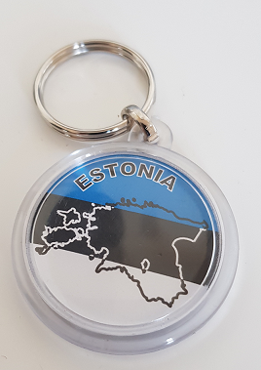

The box and all the content is designated to be trashed.

I think I will take this keyring out first. I actually do need a keyring, I really do, and now I know where I can get one. From the box of bad ideas!

I was about to make an ebook titled “bad ideas” and describe the items from that box.

## April 8

I got the idea of “modern Pandora Box”. It’s a “digital” box, it’s not hidden but it is very hard to open. If the one who opens this box uses his powers wrong then a great deal of harm will come upon us.

**B16F8501B9C596F0DC34B8805C84D656ACDCDC2E2F15A7F502D752018570C5753F196BC749C5BCADB37CBC0D54D2414D9915D53277235C8F0579CC2B0E2B46CF**

This is the “box” - it is a SHA512 hash, made from another hash (SHA512) + cryptographically strong password. The hash used to create pandora hash is made from the answer to the question: “where”. The where is related to the proposed (in my mind) location of some event, that will be explained in the Bible. EM.

pandora_hash = sha512(<sha512(answer to where?)>+<strong password>);

I, Antti Lukats herewith assure that the pandora hash is really the hash I created from the first password I selected, so the fact that it begins with "B1" is pure randomness!

Just to latch in the date I added the file “box.txt” to the Bible github into the folder pandora.

**BE-1**

:)

I got another idea about, say, it is a transportation device, a vehicle that can take us very far away. The SHA512 hash from the name of vehicle is:

**1AA...**

**1A**

**A**rmastus (Love in Estonian)

This is a challenge. This hash can be hacked. A human may be able to guess the name of the vehicle with the first attempt and be sure 100% he/she got it right without even checking the hash. A place for another extra :)

A truly random though I just had:

* Kes püüab kõigest väest saab üle igast mäest (Estonian saying)
* Schönberg
* Herzberg

Translation from estonian and german languages

* Who tries with all the strength can pass any **Mountain**
* **Beautiful** mountain - family name of my GrandMother
* Mountain of the **Heart** - birth place of my Daughter

**A Device**

I was looking for an photo from an device what I assumed I had taken some while ago - I did not find it, instead I made a mistake, I clicked in the preview on the wrong icon, here is the preview:

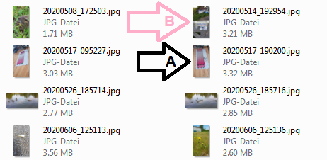

I wanted to click on the icon as pointed by arrow A, but accidentally clicked on B. Translation from the image B:

* Lächeln zu verschenken: a **Smile** to be given away as a free GIFT(on the bridge)
* Else stern: **Star of ELSE**.
* Liebe rettet leben (grafiti): **Love saves lives**.

This is an approximate drawing of the device I did assume to find a photo:

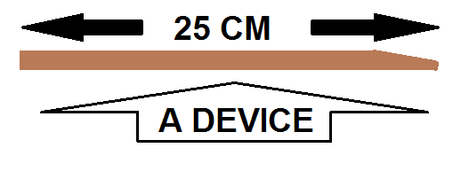

The device is made out of wood, it was in everyday use for many years. It was an important device. The day I was about to make a photo of the actual device, I had a photo shooting setup in my mind: I wanted to make a photo shot from the mirror, while I am holding the device to my heart. I am sure I actually did go pass by that mirror on the wall, to get (borrow for a minute) the device on that day. It must have been that I stopped on the way behind a closed door. I didn't take that photo. I wanted something very badly, but I did not know any further. Then I did think that there is always a person we can turn to for help. So in my mind I was writing an email to that person. I did not write or send that email. The email would have been to the **female president** of my home country - **Estonia**. There would have been a word **PLEASE** in it. After passing that mirror I did go for a walk, I had a **blue** raincoat, **black** jeans and a plain **white** t-shirt.

This T-shirt, I did buy for about 3 EUR for another photo-shooting only a few days earlier. When I realized that BLUE-BLACK-WHITE happen to be estonian national flag colors, I smiled for a second. Tears. **HELP**. Going for a walk :)

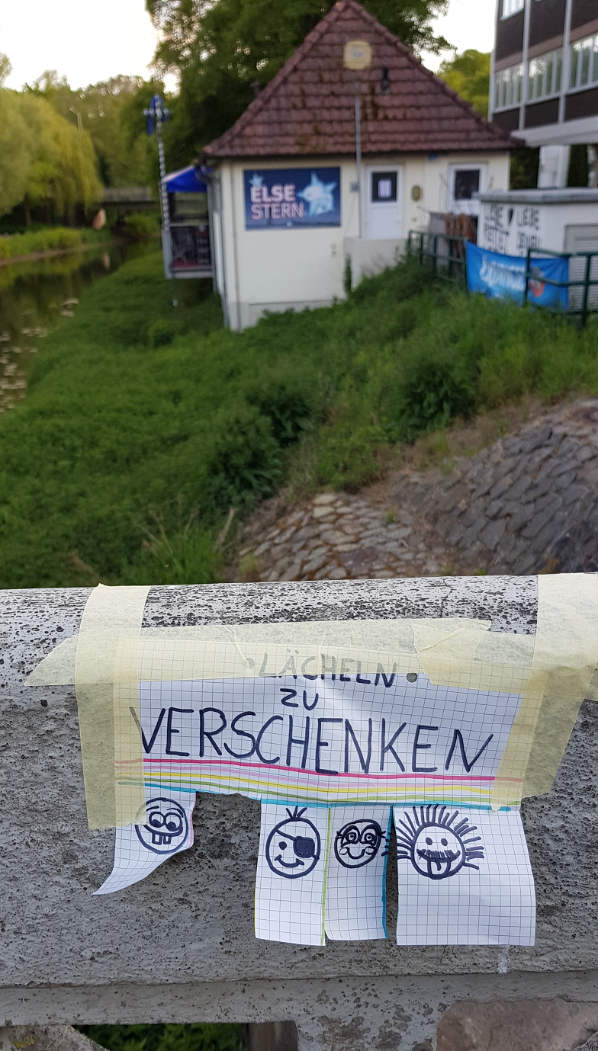

**FEAR**

In one of my browser tabs there is a video marked to be watched. The video is titled: “fear setting” or something alike. It should explain why “fear setting” may be better than “goal setting”. I haven't looked at it yet.

I am afraid that I can not take care of my family.

My fear is out. Doesn't feel any different. Or maybe it does. Time for a lunch break.

This is now a smiling place, really. **I was married during a lunch break**. Now I am hungry.

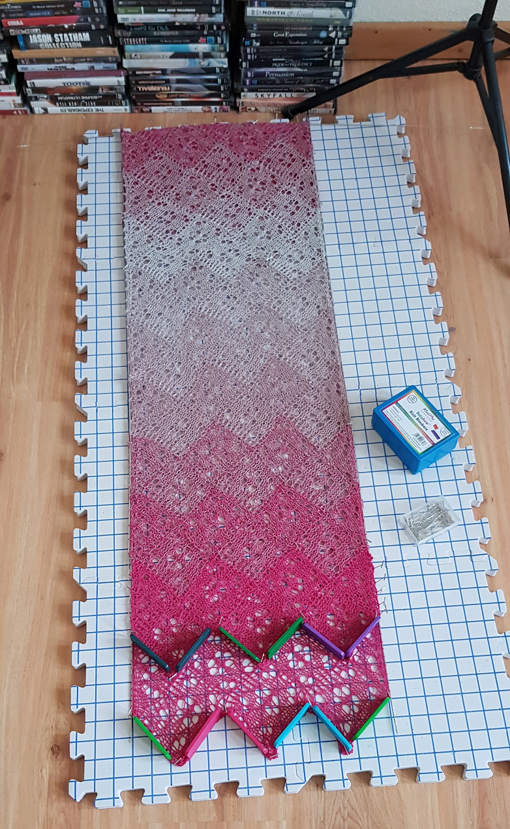

This is the photo I wanted to look at in the first place.

Kallis ma armastan sind!

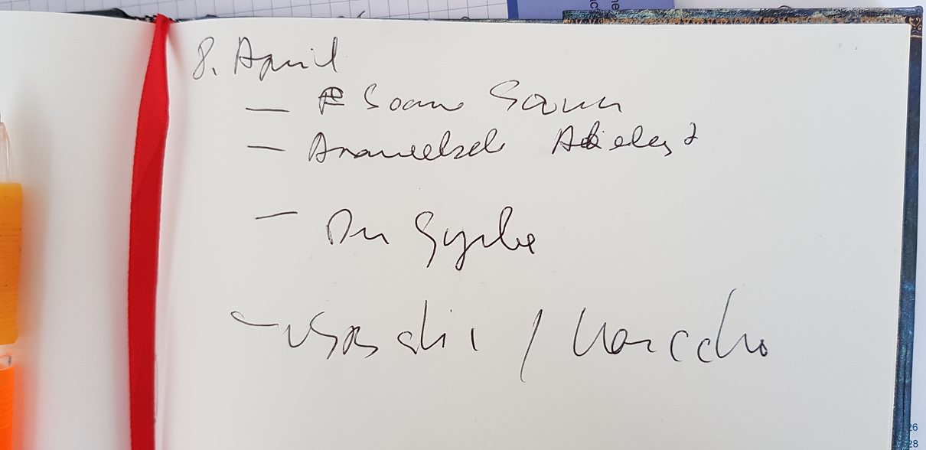

For some reason I added bullet points to my paper diary in the evening. I wanted to be sure I do not forget them, they are things to be included in the Bible.

## 9 April

Looking at my diary notes from yesterday. I can not decode my own writing, what is the first point, I can't figure it out. I do not remember. Gotcha! I did write “Soome Saun” - Finish Sauna!

I got an idea! Actually I got it yesterday. It is about the **1AA** hash, it's a really cool idea but it will not be described in the Bible. But I may reveal it at some point. What relates to this idea is [deleted content]. Well it would be cool if it would get that far that I can use this idea. There is no need to write it down for me, I do remember it, or I will recreate it adapted to the circumstances. The reason for content deletion (but not the content) will be revealed after the content is actually used in real life.

sha512(deleted content) =

**A5**...**65**

There are **5** in my family, all our first names begin with **A**, I was born in 19**65**.

I can't believe this. The content - I really removed it from the Bible for a specific reason. The removed content could be considered almost random, it could have been something else also. A few seconds ago I did think that the deleted content A5 hash is not hackable. But sometimes things change in the seconds. I am not sure any more, it could be that A5 hash is or becomes hackable.

Currently reading: “The Day of the Triffids”.

A number for me to remember: 18. I wanted to have it written down so I dont forget it. This number is a “hackable” number by the way. Actually I do have means to recreate this number should I actually forget it, but I wanted to be sure I have this number ready in my mind without the need to restore it from my “long term brain storage”. What is interesting is that there is no need for me to write down the two numbers that follow 18, I can't forget them. Those two numbers are hackable as well. :)

**Bank Error**

For some purpose (ideaREG escrow) I did lease a safe deposit box at a local bank branch years ago. Some months ago I got a notification that the rent has increased to 45 EUR/Month, I was amazed and couldn't believe this to be a monthly figure, well it felt really high and as I had not used the box at all I decided to close the lease. I went to the bank and signed the contract termination form there. Closed. Few days later a phone call from the bank, saying there was a mistake, and the rent is not per month but per year. Somehow they sounded so polite that I did not confirm the termination, and said that with the yearly fee I would like to keep the deposit box. I still had no clear idea what I should put there. Today I have, I will put a signed first copy of the Bible there.

**One Wish**

We should be careful what we wish for, right. I am about to be afraid a little right now. I have to explain a little, yesterday I did estimate a likelihood of some event to be 85..90%. This estimation was based on something I did believe to be accurate, but it was based on some of my vague memory from some random tweet. Today I entered a simple search term into google and clicked the first link. It took me less a second to change my likelihood estimate to 90..95%. A screenshot of that google first hit has a sha512 hash:

BC5BF40B62C7EBA953F73E5B7B1576F524BB3B36B2677EBA3ECA743CC0A9ED1BCAE275B307524D79C4461350F1EDA04F048A049ECEA4986ACA856EAB8D9B9761

The hash is stored as screenshot.txt in the Bible/pandora folder.

Next week I will sign that screenshot using my national Estonian ID Card so that the date is fixed when the screenshot was taken. I will also download a copy of the Bible and sign it as well, and store both somewhere.

Now to the real wish:

**I, Antti Lukats, wish that a situation would come where I would say about what my first estimate 85..90% was.**

This is now hard. Do I dare to wish it? Time to think. Yes, so be it, the wish stands. Could it become true? This wish? This one time? Can dreams become true?

[www.truedream.org](http://www.truedream.org)

Why am I still holding on to this domain for so many years?

What is the likelihood that this one wish comes true?

I truly wish this wish would become true. But I can not estimate the likelihood of it happening.

## 10 April

I am back from a walk, looking at the tablet that shows the title page of the Bible. Looking and looking. And suddenly I realize how much sense the last line makes.

B1

I added the last line a few days ago for no particular reason. I just did think it belongs there, and I added it. Today I know that it belongs there. I know why it belongs there.

I am afraid. I am afraid for Mustafa. I am afraid that he is not able to keep Injoy fitness studio open because of the pandemic. I could offer some loan? Why have I not done that? I have some money in the bank that I do not use.

A few years ago while walking I decided to check out one nice looking building, I wanted to know what it really is. So just like that I stepped in and did meet Mustafa. A few minutes later l paid for a year in advance for the fitness studio membership for me and my wife. I wish (this is now secret). This wish shall remain secret.

3S

Some years ago while I was preparing for a trip to Santa Clara I did enter the local electronics shop and asked for help to choose a smartphone. I selected a Galaxy tab and together we did choose a shell for it as well. I asked the name of the salesperson and entered it into the machine at the exit of the shop. They had a machine to leave feedback. My phone has a special feature called S-pen. For a long time I did think that it is some extra gadget that has to be purchased separately. Then one day I dropped my phone and the S-pen did fall out of the casing. S-pen is a nice extra but l have hardly ever used it. Or put it that way, I have written some notes with it but never used them. Until today. This morning I used S-pen to write a memo:

3S

A

KEY

18

:)

This was just before my morning walk. Now I am learning how to retrieve the memo, success. Ok let's see, I have to make a hash 3S.txt I do have it in my memory, I can create it. But what is the meaning of letter S in the memo? For a few moments it looked that I can not figure it out. Then it did come back to me. Good. :)

Random thought: kui Muhamed ei lähe mäe juurde, tuleb mägi Muhamedi juurde. Or was it the other way around?

Can it be true?

Before going for a walk this morning I did take a round in the garden. When looking towards the house I noticed a bird on the house. It wasn't moving, it really looked like those birds made of metal that some people put on their houses. Could it be that such a metal bird has been there for all those years and I have not noticed it? I take a photo, the bird is not moving. Can it be true? I am pretty much ready to believe that there has been a metal bird on our house all the time. And then the bird moved a bit, it was a real thing!

On the walk at some place I did stop for no particular reason. I did think, can it be? What would I see if I look closer? I was on our regular walking path, been there many times. Yet there was something new at that very place I had stopped randomly. Something that wasn't there yesterday. I am looking at it. Nothing. I am looking closer and thinking harder. No, no connection. Nothing. What I see is absolutely meaningless. I can't figure it out. Well, it was worth checking out? Some things just don't play out. And then I looked from a different angle.

I will never forget what I did see. Never.

I was good at math in the school, but I can not calculate what is the likelihood that I see what I see. Yet it is there before my eyes. I am looking closer, it is still there. I really wish to know a mathematician who could calculate the likelihood of what I did see. I think this can be calculated. Plan b. This is what I will do: I will write a short story about what I did see, then I will hash it, and store the hash as key.txt. And yes the idea of key.txt did come on the walk, the reason I did write it in the memo earlier was different. So a challenge for a mathematician, if you are ready to invest some of your time, then please contact me, I will then release the text that corresponds to the hash in key.txt, your part is to calculate the probability. I think it can be calculated.

Tammeraid!

Mathe exam in the university. There are requirements to be allowed to take the exam. I do not have them. Others are given a last chance to acquire the requirements in the exam room before the actual exam. I do come to the exam, I take my list of assignments. I sit there for two hours, I can not solve anything. Then I go forward and give an empty sheet of paper to the professor. He looks at my exam paper (that empty sheet), thinks for a second and says: I grade you 4, if you want to have a 5(the highest note) then you have to retake this exam!

Professor Tammeraid is one of 3 very special persons I have met. All of them can increase their voice loudness to very high in the middle of regular conversation. They are all amazing persons, all 3 of them.

I have forgotten something. Something important. Ah wasabi, I have it again.

I do have a paper diary, and a special ink pen I use to write.

A wooden pen.

Now there is a silent smile on my face, I did stand up to get that pen and to write a single word into the paper diary. Then I figured out that I should write exactly the opposite word. Ok, I have an idea for a binary.txt hash. I will figure the details out later.

A wooden pen.

Well as it happens, the ink did run out one day. So I did go from the development building to the office building as I had seen that there are ink refills available. I had to pass the meeting room. When I entered the room a guy from the IT asked: do you have an appointment? Of course the polite way would have been to say: I am sorry that I interrupted, I was just looking for a refill for my pen. It wasn't what I said. Later on on that day I did buy some chocolate and left it in the office building to be given to the IT guy. The refills did not match my pen, so I went to the supermarket. A smile. Can you guess what happened next? Will there be a smile on your face if you keep reading? I'm kinda smiling right now. Ok in the supermarket I did almost give up trying to identify the correct refill. I think I asked for help. I was helped. At the cashier a muslim woman ahead of me is having trouble paying, her credit card doesn't swipe and she has not enough cash to pay for the items on the belt. She is given the option to remove some of the items. There are some nice coffee mugs that she wanted to buy. Well I only have two items to pay for and I want to get it done, so I propose that I pay the remaining difference that she was short of. There would have been some 3 EUR or something to pay for me.

Time to refill my coffee mug. When returning I see that the tablet has closed the document so I have to do again the painful sweeping and scrolling to get to the place where I am writing. I do fast scrolling I am not halfway done when I reach to the coffee mug. It's not my favorite one, I wasn't able to find it, so I did take the next best one. I put the mug back and look at the tablet. It was randomly scrolled to the page reading:

Rules of Life

Back to the wooden pen: the muslim woman did not accept my offer and did not get those mugs that day. There was no way for me to make her understand that I truly know what it feels when you can't pay. I did pay for my two items. On my way back to the office (it was during lunch break) I did sit down for a moment to eat my carrot's - that other item I paid for.

And when I raised my eyes I did see the arch of Noah.

I finished my carrot's and went back to work. Ah yes, the mugs? When I reach my hand right now to drink there will be a text:

I am

before my eyes, that is the second choice mug. Full text, translated: "I am awake with clothes on, what else do you want?" And the other mug? That would read:

"Papa ist der beste" - daddy is the best. I have no idea why it is my favorite.

Back to the wooden pen. I wanted to use it today in the morning, but the refill was empty again. I decided to go to the supermarket, made preparations, like small cash, shopping coin for the cart and a medical mask. I did put the empty refill into the jeans pocket and went to pee. And what do I see?? What do you think? My hand is blue, the refill wasn't so empty at all. Actually when I look at it now it seems to be full. Washing hands. Looking in the mirror. Oh no! My face is blue too! Washing it up, success! Face is clean again, my hand is still blue. Advice from my wife: have you heard about soap and hot water? Amazing, my hand is clean as well. But I managed to have a small accident with the liquid soap dispenser, so some of the soap landed on my pullover. Well there has been another accident where soap saved the day. It was at our wedding ceremony, the rings got swapped so she did take my ring first, it did got stuck and she had to go to the bathroom to take the ring off using soap. Was very funny. Everyone at the ceremony had a smile. All 3 of us present.

During the walk today I was actually looking around to see if there is something that catches the eye to make a photo. I did some stops and had some hesitation but nothing. But then on the way back already in the city urban area I made one shot. I don't know why.

Igihaljas kuusepuu, maakera ja katkine müür - (something I do not know how to translate), world and a broken wall.

* 5 statue, was something?

## 11 April

I am a sleeper, I can usually sleep at any time. Today I couldn't sleep for a long time. At one point a terrible thought did come that I had forgotten the meaning of 1A in the Bible! Oh no, it seems I have forgotten it a second time! Luckily I can read the Bible. Phew, I have it again.

To-do list:

* gun.txt

Damnit, forgot!

* fff.txt
* 360 2
* One day

Damnit, forgot again

* letter
* Greta.txt
* Boat

If you are awake late at night and think, it is so easy to not remember it in the morning. I am sure something is missing from the to-do list.

* Trash
* A picture #1
* how.txt

It's sun

I was about to write it's Sunday, but autocomplete suggest to insert a 🌞

There was another thought I had this morning: what are the odds that I see 🌞 every time I look out of the window?

* A picture #2

I did plan to make the picture #1 yesterday, but I had to postpone it. I was only 80 meters away from the object I wanted to take a photo when my wife called, I had calculated my time wrong, she was already finished with the shopping. I will take it today.

* Open envelope with the PIN codes for my estonian ID card, I have some documents that need to signed
* Estonian embassy

Now I am really going to walk. And back, to be written later with photos and screenshots.

Ready to open the envelope with the pins. What are the odds? I am looking at the unopened envelope, there is a bar code below my name. It starts with AB!? A and B are the only letters in the barcode, the rest is numeric. I open the envelope, I do not know what I expected. I am not good anymore remembering passwords or pins, but from this envelope I can with 100% confidence be sure that I have both PIN1 and PIN2 (4 and 5 digits) when I remember:

nokia, oxygen, timer

Todo: timer!

Trash: on yesterday's walk I did pick up some paper-trash to bin it, then I did see a man ahead of me about 100 meters doing the same! He did pick up some trash to be binned! Never seen that before, I'm not the only one? I bit later there was a half full pack of napkins, I binned that too. And then I had a need to sneeze, and I had no napkins. What to-do? What I did was possibly not very wise, I did pick up a piece of paper from the ground and sneezed. And binned. On the way back close to home there was a piece of plastic waste on the ground less than two meters from a trash bin. I looked at - I don't have to pick it up? Later in the evening on my way to take picture #1 I did see the same trash. This time I did think: why not? And I binned it.

Note: no go

* vinki-vinki.txt

The other things I need to remember are saved as S-pen notes. :)

* Keeruline on lihtne (difficult is simple)
* Men on the street

I think I have forgotten something. Then I see it in the WC. I was supposed to make one another photo today. I think. And I think. What if? What if instead of that final photo I create: final_photo.txt ?

Beep beep bell comes from the kitchen. It stopped.

Yes, I will go running today.

* A guy, 5

I will :)

;)

Korv õuntega - I need to translate this. Or do I?

I can't sleep, toblerone

When is my mother's birthday? Can it be? Does it matter? Can I find it out someway? My grandpa and father are in wikipedia but my mother is not, hmm If I wait enough then google would send a birthday reminder? Not sure. But I do want to know.

* Origin
* 50%
* 5T
* RK
* letter.txt

Do it now. Going running. If there is something I have forgotten so be it.

* Debt
* 5C

Now I really must go.

I am glad I did, I may have to reevaluate everything.

## 12 April

I didn't sleep well, again. I did have a dream, a bad dream, something happened because of me and I was ashamed of that. A friend of mine has terrible dreams every night, he is fighting to protect his family. Every night.

Today I did stand up early, this hasn't happened for a long time.

I have a plan!

* 2E (second meaning)
* 3L
* LG
* F1A
* Keyring
* 2A

I am trying to remember my plan. I had one, right?

Ah yes:

* Suicide a book by ?
* Idea
* Coffee is ready.
* Contract
* Etendus(a show)
* A meal
* Dinner
* A tick
* A beautiful day
* I have forgotten something?
* Bread
* Eclipse
* Red moon
* Battery back

I must have forgotten something. Ah yes I wanted to write:

* 300:3
* 100SEK
* Deadline 13

Ah !

* Signature
* September
* MYS
* SID
* JAF
* Zilog

I know I have forgotten something! I just know!

* ERA
* .
* RIP Mike
* Kapp(closet)
* Two rings
* A ring
* Prince

:)

It's still only 07:40 AM!

* CV
* (Something I really forgot)
* Church
* 5B
* Dedication

07:50

* A choice
* Mathe
* KRUVI
* A or B
* Dentist
* A cell phone

:)

08:15

Carrot time!

* A book!

Carrots and water, it really helps, it’s at least two things I had forgotten!!!

* LOVE
* LAW

Phew, I am so glad I remembered!! It was a close call.

Damnit, now I really have forgotten something, and this time it seems I can recall it. Is it really so? That I can’t remember?

Another Carrot!

I have it :)

Just for a second, I did think I lost the “memory item”...

Can you believe WHAT I had just now forgotten?

* secret to-do item list item is done, saved screenshot: failure_point_1.jpg

Damnit, how many things can one man forget on one single morning??

* MAFA21

Water! I was about to bring new water from the dispenser! Going!

08:45

* HUMAN
* ARTI

08:55

* A bike

08:57

Do I have NOW recalled all the things I did think about at night being awake? Yes :)

= = =

DEADLINE, need to focus to keep it.

Still one more item from my long “forget” list:

* A Plea
* A Place

Ma pean sügavalt sisse hingama. Juba parem! Nii nüüd tuli üks POPUP:

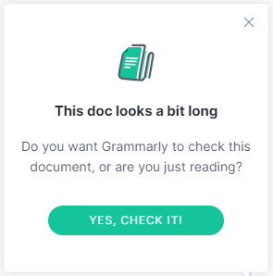

Dear Grammarly, I am writing but thanks for asking!

Time for my morning smoothie.

* A Door, 360 - this is now a NEW idea, but I think it is a good one, let’s make it as door.txt !

My memory really isn't what it used to be, there was one more item on the early morning list:

* Landlord

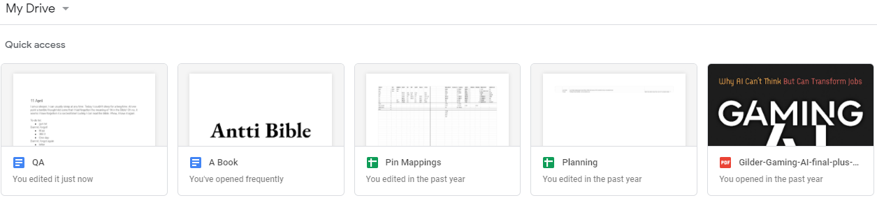

The QA is just a temporary text as on my table sometimes the Bible editing does not work for unknown reasons.

There are now two empty envelopes on my desk, to whom should I write?

What do you think? Will they be received and read? What response do I get?

I do not know, but I will write those two mails today. It shouldn't take that long.

Change of plans, less is more!

This now something from some while ago [more than a year]

* A question to the president of Estonia [Kalle]

This really can not be true, just a second ago I did recall another item from the morning list, but this time it lapsed again. It’s gone. Oh, well gone then gone.

5,4,3,2,1,0 ma parem teen selle kohe ära!

Ma tegin ära! Ma kirjutasin kirja, alla kahe mintsi läks. Trükkisin ära ka! Valmis. Ümbrik kinnikleebitud. Aadressi pole vaja, kirjutan ümbrikule lihtsalt nime peale, sellest aitab. Mis sa arvad kas sa oskad ära arvata kellele ma kirjutasin? Kui oled piiblit lugenud siis on sul päris head vöimalused see ära arvata! :)

Üks tühi ümbrik on mul veel, mis sa arvad kui kaugele see kiri läheb? Jöuab ta üldse kohale, asi nimelt selles et ma ei tea tegelikult kuhu ja kellel ma peaksin selle teise kirja üldse kirjutama. Ja ma ei tea kas sellest üldse kasu oleks, aga ma otsustasin eile et me kirjutan selle kirja. Ja tehtud see sai. Teise kirjaga on lugu natuke keerulisem, tahtsin teha hästi soliidse kirja ja kirja sissse panna enda foto mille lasin spetsiaalselt foto ateljees teha. Valge särgiga olen ma sea fotol. See esimene kiri on tähtis aga teine kiri on veel tähtsam, mis te arvate kui kaua mul teise kirja kirjutamine aega vöttis, ideest kuni ümbriku kinnikleepimise? Ma ei tea kui kaugel meil siin printer minu kirjutuslauast on, aga sinna köndides jöuan ma rahulikult 40 ni lugeda. Mis oleks kui teeksite mingi võistluse et kes paneb köige paremini täppi? Kes pakub rohkem? Kes pakub vähem? Mul on teile preemiaks üks smiley :)

Mis te arvate mis värvi majas ma elan? Kes arvab ära? Mis te arvate kas ma oskan hinnata teie pakkumisi oma laua taga istudes? Proovime, ma pakun välja et enamik (üle 50%) lastest arvaks esimese korraga ära mis värvi majas ma elan.

Aga kes on mr Wolf? Ka sa seda tahaksid teada?

Just praegu ma avasin ühe raamatu selle koha pealt kus oli järjehoida. Ja ma ei usu oma silmi. Arvake ära mis seisab seal numbri 24 taga? Ja miks see on tähtis? Ja mida ma mötlesin kui ma kirjutasin raamatusse number ühe ja tömbasin sellele pastakaga ringi ümber?

Ah et miks ma inglise keeles kirjutan? Sest ma tahan et minu raamatut loeksid inimese suured ja väikese paljudest maadest ja selle pärast on inglise keel vajalik. Praegu kirjutan eesti keeles sellepärast et panin ühe tähtaja paika 13 April, tahan ühe asjaga selleks ajaks valmis saada ja eesti keeles kirjutamine läheb mul kiiremini.

Aga ka sa seda tahaksid teada kuidas ma inglise keelt õppisin?

See on üks asi mida ma ei suutnud eile otsustada kas teha vöi mitte, aga kui ma praegu vaatan seda eset mis on muu ees laual, see on hõbedane ja selle peal on pilt. Mis sa arvad mis loomast? Ei see ei ole rebane. Aga kas sa tead miks rebane on väga tähtis (inglise keeles: FOX)?

Ma lisan ühe võtme oma võtmerõngas, see oligi see asi mille kohta ma eile kindel ei olnud. Kas tead miks ma köhklesin? Kui mul meeles püsib ma võin sellest rääkida.

Ah peaaegu oleks meelest läinud, kas sa tahaksid näha millises majas ma praegu elan? Oi nüüd ma olen kurb. Tegelikult natuke ainult. Asi on nii et kui ma paar aastat tagasi kirjutasin google otsingusse oma tänava nime ja maja numbri siis oli esimene hit PILT sellest majast kus ma elan. Aga google otsing muutub ajaga, täna on pilt majast kus elan kolmandale reale nihkunud. Nuuks. ;) Aga tegelikult pole see üldse tähtis mitmendas reas me oleme. Ja ka see pole tähtis kus me elame vöi mis värvi maja on. Tähtis on elada.

Mis asja ma näperdan, ma pidin ju ühe võtme lisama röngasse, see on tähtis. Tehtud.

18a vs 50MUSD (see on lihtsalt üks kõrval mõte mis tuli miskipärast pähe, hiljem seletan)

Ah, jah see raamat mille ma hetkel avasin, jah sealt kus oli MIS VÄRVI järjehoidja? Mis sa arvad kas see jutt seal avatud lehe kohal, ka see on kuidagi seotud sellise mehega nagu Warren Buffet? Ja numbriga: 5 ?

Ka sa oskad ära arvata mis raamatust on jutt?

See on lihtsalt jumalik, ma just praegu näperdasin ühte asja. Ja siis ma vaatasin et mida ma näperdan. Täitsa uskumatu päegu kui nüüd järele mõelda. Aga muhelen natuke. Ma olen seda asjandust ilmselt juba pikemat aega näperdanud sest kiri hakkab juba kuluma. See on tegelikult ka üks väga tähtis asi, töövahend. See kiri mis on pooleldi kulunud haakub ühe firma nimega mida ma kunagi omasin. Sellel minu firmal oli tookord isegi posti aadress linnas nimega Seattle. Huvitab kes arvab ära mida ma praegu näperdasin? Võimatu see pole, ega ma väga ei imestaks kui see juhtuks. Aga mis ikka lobisem, teen parem ühe foto sellest asjandusest, pärast võtan sellest failist SHA512 hashi ja laen githubi ülesse. Pilt tehtud, häshi tegemisega pole enam kiiret.

Ah, tuli veel üks asi meelde mis ma hommikul poolunes olles sellese nimekirja tahtsin panna, imelik kuidas asjad vahel meelest lähevad ja siis ootamatult jälle meelde tulevad.

* IBM

Nimekirjad, mingi hetk olen ma ühte nimekirja lisanud: raamat LASTELE

Ei tea küll miks? Aga nimekirjas see seisab, must valgel. Nüüd ma ei tea mida teha, tahaksin selle nimekirja kohta teha ühe väikese vihje. Aga ma kardan et rikun selle hea mängu ära et kui tahab ära arvata mis nimekiri see selline on.

No see on küll lahe, ma ei leidnud klaviatuuri seda õ ülesse, kirjutasin sellepärast igale poole ö tähe, aga google doc tegi kõik need sõnad punaseks ja hiirega saan kõik need ö tähed ära parandada. Google oskan tõesti eesti-inglise keelset spell checkida.

Ah jaa, mulle võib kirjutada eesti, soome, inglise, saksa ja vene keeles. Aga enne kui kirjutad loe palun uuesti ROL 2001 reegleid. Ma ei tea kas ma vastata suudan ja jaksan.

Jälle tuli üks asi meelde, aga enne kui sellel mõttel sabast kinni sain pani uuesti putku. Hetk tagasi olin kindel et no see mõte nüüd küll enam tagasi ei tule, aga tuli!

* Dream Company

Sini-must-valge

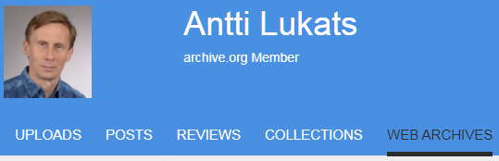

Tead kuidas ma selle pildi tegin? Ma läksin foto stuudiosse ja ütlesin et mul head pilti vaja. Tegelikult tahtsin ma neile öelda et vajan pilti, noh et seal pildil oleks näha et ma suudan minna tähtede juurde. Ütlesin et “money is no object”. Tjah nad ilmselt ei saanud sellest aru et mul oli too hetk täiesti kama kaks palju selle foto eest maksta. Ma ei oska ennast eriti hästi väljendada. Ma maksin 28 EUR hinna sees oli ka täitsa kobe Toshiba USB-Stick mida saab hästi võtmerõnga külge panna.

Nüüd ma ei mäleta ka ma olen olen sellest juba äkki kirjutanud, plaanis oli, meeles pole, aga ma kirjutan uuesti mis siis kui saab sama asja korratud. Ühes tviidis Greta Thunbergi kohta ütles keegi “we stan with Greta”, ma ei enam kindel ka ma seal, oi see on NALJAKAS kohe jube naljakas. :) pisike muie mu näol. Tahad nalja? Vaata ma tahtsin kirjutada TWEET eesti keeles, ja kirjutasin selle eesti v tähega. Google markeeris selle punaseks, VIGA. Ja tead mida ta paranduseks pakkus? Oi ma ei suuda :)

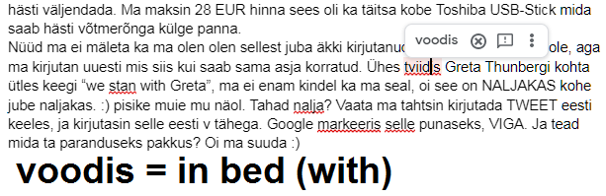

Vesi sai otsa. Pean uue tooma, juba teine pudel täna, teen edusamme.

Oi, aga mul jäi jutt hoopis tükis ära rääkimata, see millest ma tegelikult kirjutada tahtsin:

Pole teil midagi vaja stannida, **Greta läheb tähtede juurde üksi** ilma tagasi vaatamatta.

Ja mis sa arvad kuhul nüüd on vaja minna? Öige! Vahel tuleb pissil ka käia. Ma käin päris tihti pissil, pean vist arsti juurde minema, aga ei saa seda kuidagi ette võetud, pole viga vets on minu kirjutus lauale hästi ligidal, pole kaugele vaja minna.

Ja mida ma nüüd pidin õigupoolest tegema?

Ah, pissil pidin käima ja vett pidin tooma. Oi pidu aina paraneb, mis sa arvad mis ma kohvikust kaasa töin? Ma vötsin kohe kolm, maksta polnud vaja. Ma teen sinu jaoks foto.

maiustused.txt

Oi täna no kohe tulevad naeratused. Vahel kohe on selline päev. Täna, ja homme ka. Aga loomulikult sõltub see ikka meist endist kui palju meile naeratakse. Aga tüdrukud seal tootmishoones hommikul kui ma tööle nad tõesti, no kohe tõesti naeratasid nii ilusti, justkui oleks täna mingi eriline päev. Aga ei ole ju, on lihtsalt uue töö nädala esimene päev. Aga kui sa nüüd ära arvad mis küsimusele ma praegu vastust otsin, no siis tahaks sulle küll kommi anda. John oli eelmine nädal puhkusel, ja no kellelgi oli sünnipäev, no ma siis võtsin kolm maiustust ja viisin Johni lauale et puhkuselt tulles, noh tegelikult ma ei tea mida ma täpselt mõtlesin.

Mötted tuleva ja lähevad, WATERDROP!

Sain möttest kinni, aga napilt. Hihi, SAIN VEEL ÜHEST hommikusest mõttest kinni:

* Vault
* Ara

Kätte sain!

Täna võin lõuna küll varem teha. Aga kell ongi juba peagu 12. OOTA et jälle meelest ei läheks, ka ma 5B panin juba nimekirja? Tead päris kindel et panin, aga noh topelt ei kärise.

Oi, veelest ühest sabast sain kirja, tegu on ühe küsimusega.

Kas sa jumalat usud?

No kurat seda sa nüüd küll ära ei arva ei arva.

KELLELE ma plaanisin selle küsimuse esitada?

Oot **KES** ütles vöimatu?

KELLELE ?

Arva ära. Vöimatu see pole. Vahel on lihtne keeruline, vöi oli see vastupidi? Kes kurat seda nii hästi teab. Aga nüüd küll kõhus koriseb.

Vaheaeg.

Miks ma praegu kirjutasin vaheaeg seda ma tõesti ei tea.

Oi veel ühest sabast sain kinni! No see oli nüüd küll vedamine!

GUIDO KANGUR

Paus, pean tõesti pausi tegema.

Oi, kurat, veel üks saba. Kinni sain!

twitter.txt

Maggi supp on ahjus, sain veel ühe saba! Täna ikka on üks sabade päev.

pain.txt

No minuga ikka vahel juhtub igasugu asju, arvad ära mis siis täna juhtus?

lunch.txt

Aga ma pidin hoopis veetilgast (waterdrop) jutustama. See polegi tegelikult veetilk, lihtsalt ühe firma päris leidlik “brand name” nad toodavad vee lisandeid, pisike kuubik, paned tavalisse või kui soovid gaseeritud vette ja möne minuti pärast on sul mõnus jook valmis. Aga on palju neid inimesi kes veetilgast väga palju uut ja huvitavad oskavad rääkida. Mina ei oska.

1!

Vot see oli tõesti hea idee, just praegu tuli. Tõsiselt hea. :) Natuke järele mõeldes, noh ütleme nii et, no see ikka on hea idee. OOT, aga keegi võib selle idee ju ära varastada? Minu peast? See et keegi mõtleb välja MILLEST ma just praegu mõtlesin ei ole võimatu.

PAUS

Kes arvab ära mida ma just praegu pausi ajal mötlesin?

No seda pole küll võimalik ära arvata!

paus.txt

Vahel on tõesti tähtis väike paus teha, see võib olla kohe eluliselt tähtis. Kas teate lapsed mis ma asjast arvan peale väikest pausi? Keegi teist mõtleb välja millest ma praegu just mõtlesin, pole see nii võimatu ühtegi.

Toho tillae, kas asi võib veel paremaks minna. Mulle tuli mõte et peaks ühe vana sõbraga rääkima. Siin on väike kahtluse moment, keeruline seletada, ok kahtlemiseks polnud põhjust. OOT, OOTA! Rahu ainult rahu ütles Karlsson katuselt. Ok kõhklus tuli sellest et ma polnud oma söbra messengeri avataris kindel, see on kuju ühest tegelasest. Ma olin endas suht kindel et ma ei eksi, et tean kellega on tegemist. Nüüd teen ma järgmist: ma teen screenshoti oma viimasest vestlused oma sõbraga. No seda nüüd küll keegi ära ei arva. Või mis sa arvad asjast?

avatar.txt

Minu viimast repliiki pole eriti raske ära arvata, aga mida mu sõber ütles?

Tähelepanu, tähelepanu! Ma pean rohkem tähele panema muidu unustan mõne tähtsa asja ära! Ma pidin ju küsima mis sa arvad palju maksid margid nende kahe tähtsa kirja peal mis ma täna kirjutasin?

Miks on

!

Tähtis?

No, täna on ikka üks unustamiste päev! Ma teen midagi igal tööpäeva hommikul, see juba suht rutiin. Täna läks peagu meelest! No kas saab minna veel paremaks. Jälle see google oma autokorrektoriga! Vaata mis ta teha tahab!

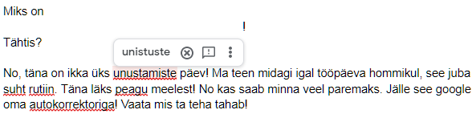

Tuleb kiiresti ära teha see rutiine asi! Tehtud!

tehtud.txt

No nii, kas sa oskad arvata mida ma järgmiseks teha tahan? See on suht lihtne ära arvata.

tahan.txt

Oi, veel üks mõte tänasest unetust ööst: See on minu kõige kallimast asjast (rahalises mõttes). Hea et meelde tuli!

No, ikka on vöimalik unustada!

[www.antti-bible.com](http://www.antti-bible.com)

Kuda ma selle ära unustasin?

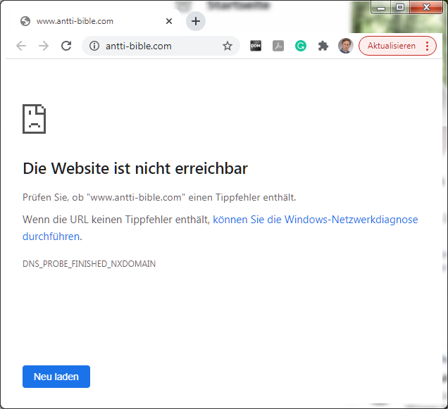

Oot oot, mul jäi ju midagi pooleli? Mis see oli ka sa tead? Aga kuidas seda teha, korra ma nagu teadsin, aga nüüd ei leia üles. Ah polegi nii keeruline, ei pidanud isegi googeldama.

screenshot_1320.txt

No nii lihtne see nüüd ka polnud kui algul tundus! Hakkam sain, kell on 13:27!

Ja näe, jälle korra pissil käidud! Peegli ees KURAT :) LOL: ROTFL.

Ma hakkasin vetsus peegli ees itsitama. Mis sa arvad kui palju raha oleks vaja maksta, selleks et keegi “mõtleks” välja miks ma peegli ees itsitasin? Ah et mõtete lugejaid pole olemas? Ja pealegi on see mõte ju juba minevikus?

Võimatu?

Jutt sai otsa, vist aeg pisike paus teha.

13:36

Seekord oli pisike paus. Mulle on vaja uut telefoni. Kas sa tead miks? Mõtle välja.

FORCE

No seda pole nüüd küll võimalik välja mõelda miks ma FORCE kirjutasin. Või siiski?

force.txt

Focus, Focus! Ma panin endale ju tähtaja, 13 April, ja nii palju on veel teha! Oot, mis see siis ikka on mis ma 13 ndaks valmis pean saama? Ok, see mis kindlasti tuleb teha - lisada piiblisse:

* viimased S-pen notizid,
* fotod ja
* screenshotid eilsest jalutuskäigust

Kui nüüd hästi järele mõelda siis suurt rohkem polegi vaja midagi nii hädasti teha. Kõike muud võib hiljem rahulikult teha.

Veel ühest sabast sain kinni

* 1600 EUR

Haaaaigutus! Ja veel üks saba!

* 5%

Täna ikka jätkub neid sabasi eks ole?

Otsin neid S-peni notize, leian FB nimelise folderi DCIM seest, ja OI. Oi oi oi. Seal on 1 pilt. Ja missugune pilt see on! Ma ei otsinud seda pilti sealt, ma teadsin et mul on ta olemas aga ma ei arvanud et telefuni sees. SCREENSHOT

Pisarad.

screenshot_1403.txt

OTSUSTUSJULGUS

Ma tahan midagi teha, aga ma peaks oma abikaasalt selleks luba küsima. Silmad on märjad. Hingan sügavat sisse. Tead kallis, seekord, tead ma teen selle ära! Ilma küsimatta!

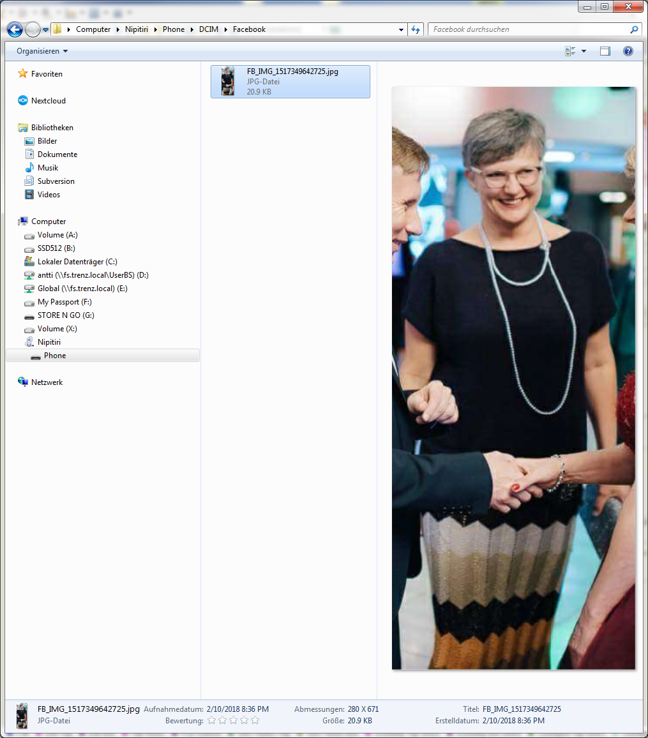

Nii, kui ma kuskilt need S-Pen notizid üles leiaks, küll oleks hää. Olen nöutu, kus nad on?

Aga kui natuke rahulikult järele möelda kes kurat ütles et ma PEAN need notizid siia kopeerima, äkki piisab sellest kui neil oleva teksti kopeerin siia?

LIFETIME.

I am Lost ?!

GONG. here was some drawing too, I did DRAW the Gong!

Church - - - - - - - - X

Path?

CW AW?

#3 [a name] :) JA [a name here to be revealed later]

Done, wasn't even 2 minutes :)

Now, vabandus hakkasin vahepeal inglise keeles kirjutama! Aga mis sellest?

Ok, now I need to insert the photos? Say who? Would it be sufficient if I zip them, and take SHA512 and upload it to github? Sure it is. It must.

DONE

With important things. Minor paperwork remains.

A short walk to see my wife.

A hug.

Tänaseid tegemisi ära jäta homse varna? Või kuidas see kõlas? Ma vöin selle kui kohe ära teha ja süda rahul? Teeme ära?

**JAH**

Nüüd ma salvestan selle faili ja teen selle ära. Ah, PEAGU oleksin unustanud, ma tegin ühe vea. Ja ühe vea mida ei saa parandada! Kas tead millise? Mötle välja! Oota see kas seda saab välja mõelda sõltub sellest kas, see on mulle tundmatu faktor. Ma ei taha ju sulle võimatut ülesannet anda täna. Oot aga ma saan seda ju kontrollida :)

Kurat mingi, jama agaa kurat sellega, hiljem jõuab seletada küll.

14:28PM

Aga miks mitte täna? Kui all jalutams käisin, seal oli palju naerul nägusid.

Ai, kui ma nüüd googles wordi impordin siis lähevad 2 SUN smilit kaduma, aga sitta sellest ei hakka seda viga praegu parandama. Ja formateerim ja vigade parandust ka tegema ei hakka! On nagu, mis seal ikka.

# 

# Q & A

“The man who asks a question is a fool for a minute,

the man who does not ask is a fool for life.”

Confucius

Asking questions doesn't mean you're the stupidest person in the room; it usually means you're the only one brave enough to speak up.

## How to ask a question?

## Where to get answers?

Twitter: What is your purpose in this life?

* To help wherever I can. To share the love I have.
* To help others. Isn't that why we're all here?
* To uplift and inspire.
* To be kind and make people smile. And to find happiness myself while doing that.
* To leave the world a little better.
* First do no harm. Second, have fun.
* Spread compassion and kindness like fairy dust.. oh and save mother earth.
* To try and be a little bit better each day.
* Be the reason someone feels welcomed, seen, heard, valued, loved and supported.
* To learn as much as I can.
* To be as kind as I can to as many people as I can.

A purpose of human life,

no matter who is controlling it,

is to love whoever is around to be loved.

Kurt Vonnegut jr

# 

# Writing and Creating

To practice any art, no matter how well or badly, is a way to make your soul grow.

So do it.

Kurt Vonnegut

Writing and publishing have never been so easy as it is now. There are many online platforms that are free. We can of course write offline too.

Important: whatever we write online or publish to some website may be tagged to our name forever. We can not take anything back if it has been available online once.

Why do we write?

1. For money
2. For fame (and to feel being liked)
3. Just to help others
4. To help ourselves (letting it out)
5. To save the world

I have opted for option 5, to save the world by writing a Bible.

I have used different tools for writing, usually Microsoft Word. Only to find out that the document I want to edit is not accessible from where I am, so recently I am writing more and more online using Google Docs. I was positively surprised about the usability of Google docs, and its accessibility from mobile devices. I can edit the Bible from a desktop PC or at home on the Android tablet, and if needed even on my smartphone. A nice extra is a free version of [Grammarly](https://app.grammarly.com/) that installs itself into Google docs and proofreads your text and makes suggestions to fix and improve your writing while you type.

## Your Book Sucks and Here’s Why

I am looking at the [hotlist of Writing Guide](https://www.wattpad.com/stories/writingguide/hot) stories at [wattpad](https://www.wattpad.com/home). Does the Antti Bible suck? Should I read the story “[Your Book Sucks](https://www.wattpad.com/story/36671166-your-book-sucks-and-here%27s-why)...”? Let’s use the 5 Second Rule! 5,4,3,2,1, GO: I am already reading the story, looking at the table of contents. It seems to be related to fiction writing only, so it’s not applicable to the Bible. Maybe the last chapter: “Write A Book In Seven Days” is of interest, checking out what it says - check out my other book called: “Complete A Book In Seven Days”? And that other book can not be found. And this story is listed #2 in Writing Guide stories at wattpad.

## How to Write Stories People Will LOVE

This is the title of #1 hotlisted [story](https://www.wattpad.com/story/86899310-how-to-write-stories-people-will-love) in Writing Guide at wattpad. Clicking on the table of contents, scanning the section, reading at the end:

Write because you love it

Or: do what you want to do. Taken from my own Rules Of Life. I think this story deserves being rated #1.

## License and Copyright

Any creative work (including code) is under exclusive copyright by default. Nobody can copy, distribute or modify your work if you have not added a copyright. And once the work has other contributors, “nobody” starts including you.

So as soon as we publish (or plan to publish) something we should add copyright notice and or license. How to choose a license? There is a website: [choosealicense](https://choosealicense.com/) if you want to select an open-source license for your work. Note that no license doesn’t mean that others can use your text or code. An open-source license allows the reuse of code while retaining copyright. A public domain license would remove all restrictions. Note that a public domain license is not the same as no license, the public domain license most likely includes limitations on liability and warranty. Examples of public domain licenses are:

* [unlicense](https://unlicense.org/) - simple short license
* [Creative Commons CC0](https://creativecommons.org/share-your-work/public-domain/cc0/)
* [wtfpl](http://www.wtfpl.net/) - do what the F*** you want todo

CC0 includes some heavy legal text already. A very long time ago I sometimes did write “public domain” in the source code file headers, this is not as good as giving reference to a known public domain license.

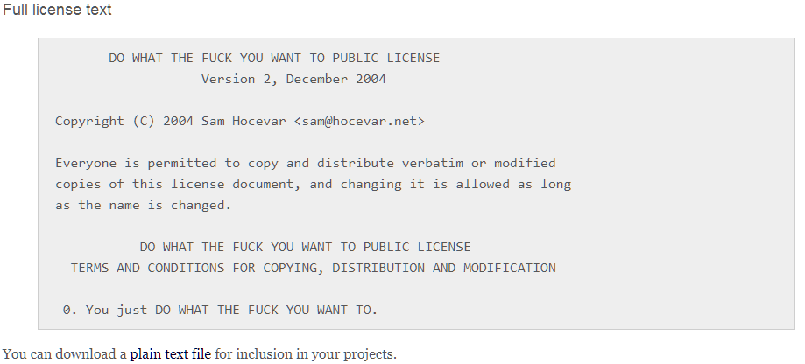

I would really not use the WTFPL license ever, I would go with CC0 when choosing a Public Domain license. Creative Commons offers an online tool to generate the CC0 license and text for you.

## 

## README

Readme is exactly what it says it is, it is something that should be read. README is the de facto standard file name for short descriptions for some file(s) or an archive or project. And sometimes the complete project may consist of the README file alone.

Udacity offers a free course: [Writing READMEs](https://www.udacity.com/course/writing-readmes--ud777) this is a good resource. Maybe even a bit too complicated as it talks about markup too much. There is no direct need to use markup.

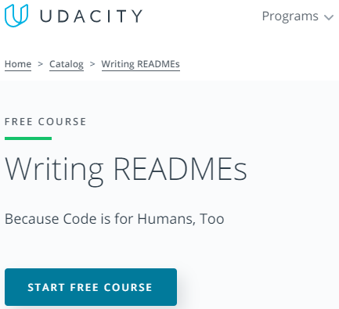

In short: README files are written by humans for humans. Some tools and environments may enforce the creation of default readme files, but their content should be written by the author. A readme file is the absolute minimal documentation for a set of files or project. It is important to realize that when we write a README, then it is for us, for our coworkers and for the users. We often can forget things, so when we find some old project of ours without **readme** we may not instantly recall what it was about. I just created some 5 new readme files for some old projects that I pushed to GitHub. There are no rules about what should or should not be in readme or how to write it exactly. We should try to give some minimal info about the project and how to use it, what are the requirements, where to get additional information. Readme files should be viewable on any platform, the best is to stick with plain text and ASCII character set. Simple markup can be used as it retains the readability. When you write a readme file in Microsoft Word you should also include a PDF version as well. If README is all there is, then info about author(s) and copyright can also be included there.

# Quotes

“If we have not found something worth dying for, we have not found anything worth living for, and if we haven’t found anything worth living for, we haven’t found anything worth dying for”…

"Anything worth living for," said Nately, "is worth dying for."

"And anything worth dying for," answered the sacrilegious old man, "is certainly worth living for.”

Joseph Heller, Catch-22

“If a man hasn’t found something he will die for, he isn’t fit to live.”

Martin Luther King Jr.

“Do all the good you can.   
By all the means you can.

In all the ways you can.   
In all the places you can.

At all the times you can.   
To all the people you can.

As long as ever you can.”

John Wesley

"I want to be better...

We can always be better…

We all can be better…"

Antti Lukats

"Isn't atheism just another religion? No, it isn't. Atheism has no creeds, rituals, holy book, absolute moral code, origin myth, sacred spaces or shrines. It has no sin, divine judgement, forbidden words, prayer, worship, prophecy, group privileges, or anointed holy leaders. Atheists don't believe in a transcendent world or supernatural afterlife. Most important, there is no orthodoxy in atheism."

Dan Barker, Godless

"There is no destiny, until you begin the path of life!"

Unknown

"Eyes are useless when the mind is blind."

Unknown

"Don't just teach your children to read. Teach them to question what they read. Teach them to question everything."

George Carlin

"I don't have everything I love, but I do love everything I have."

https://meeldib.elu24.ee

This was on the Facebook account of an Estonian user whose handle is "armastan" (I do love). This user is posting a large amount (1000++) of beautiful photos, with short sentences/quotes and good wishes. I'm reading the quotes: "Do not hope others like you if you don't like yourself..." Do I like myself? This is a hard question. I do like to think that those who know me know that they can depend on me when they are in need. There probably aren't many who know me.

"Focus on what you want to achieve, not what you are afraid of!"

"You have one duty in this life: duty to be happy!"

Recipe for a happy life:

eat less, move more, buy less, do more, worry less, smile more, hate less, love more

and find in each day at least one moment to enjoy a little silence and your own company.

"Move on with your life - simple words to say, and so hard to fulfill."

"Even your greatest enemy can't harm you as much as you yourself with your thoughts."

"If you can make someone happy then do it, the world needs more happy people."

"I don't ever lose, I win or I learn."

"To keep your happiness you have to share it!"

Mother Teresa

"There is no time, only a moment.. that's why all strength must go into this moment!"

Lev Tolstoi

"Smile always, when possible! A smile is the best greeting and cheapest medicine!"

I am scrolling through the photo collection and wondering about this Facebook user, who is he, and why is he posting so many photos? All photos are watermarked with one of two websites, either armastan.ee or meeldib.ee, so checking them up. Ah that's why, it is all social engineering to drive web traffic to elu24.ee website, that was the trick! It's all about money, pay per view clicking. I wonder how many image copyrights is this user violating?